UNITED STATES
SECURITIES AND EXCHANGE COMMISSION
Washington, D.C. 20549
___________________________________
FORM 8-K
___________________________________
CURRENT REPORT
Pursuant to Section 13 or 15(d)
of the Securities Exchange Act of 1934

Date of Report (date of earliest event reported): July 15, 2026
___________________________________
M&T BANK CORPORATION
(Exact name of registrant as specified in its charter)
___________________________________

 |  |  | New York
(State or other jurisdiction of incorporation)
1-9861  (Commission File Number) |  |  |  |  |  | 16-0968385  (I.R.S. Employer Identification Number)
One M&T Plaza, Buffalo, New York |  |  |  |  |  | 14203
(Address of principal executive offices) |  |  |  |  |  | (Zip Code)
Registrant's telephone number, including area code: (716) 635-4000
___________________________________
Check the appropriate box below if the Form 8-K filing is intended to simultaneously satisfy the filing obligation of the registrant under any of the following provisions (see General Instructions A.2. below):
☐ |  |  | Written communications pursuant to Rule 425 under the Securities Act (17 CFR 230.425)
☐ |  |  | Soliciting material pursuant to Rule 14a-12 under the Exchange Act (17 CFR 240.14a-12)
☐ |  |  | Pre-commencement communications pursuant to Rule 14d-2(b) under the Exchange Act (17 CFR 240.14d-2(b))
☐ |  |  | Pre-commencement communications pursuant to Rule 13e-4(c) under the Exchange Act (17 CFR 240.13e-4(c))
Securities registered pursuant to Section 12(b) of the Act:
Title of Each Class |  |  | Trading Symbols |  |  | Name of Each Exchange on Which Registered
Common Stock, $.50 par value |  |  | MTB |  |  | New York Stock Exchange
Perpetual Fixed-to-Floating Rate  Non-Cumulative Preferred Stock, Series H |  |  | MTBPrH |  |  | New York Stock Exchange
Perpetual Fixed Rate Non-Cumulative  Preferred Stock, Series J |  |  | MTBPrJ |  |  | New York Stock Exchange
Perpetual Fixed Rate Non-Cumulative  Preferred Stock, Series K |  |  | MTBPrK |  |  | New York Stock Exchange
Indicate by check mark whether the registrant is an emerging growth company as defined in Rule 405 of the Securities Act of 1933 (§ 230.405 of this chapter) or Rule 12b-2 of the Securities Exchange Act of 1934 (§ 240.12b-2 of this chapter).
Emerging growth company ☐
If an emerging growth company, indicate by check mark if the registrant has elected not to use the extended transition period for complying with any new or revised financial accounting standards provided pursuant to Section 13(a) of the Exchange Act. ☐

Item 2.02. Results of Operations and Financial Condition
On July 15, 2026, M&T Bank Corporation (“M&T”) announced its results of operations for the quarter ended June 30, 2026. The public announcement was made by means of a news release, the text of which is set forth in Exhibit 99.1 hereto.

The information in Item 2.02 of this Form 8-K, including Exhibit 99.1 attached hereto, is being furnished and shall not be deemed to be “filed” for purposes of Section 18 of the Securities Exchange Act of 1934 (the “Exchange Act”), or otherwise subject to the liability of such section, nor shall it be deemed incorporated by reference in any filing of M&T under the Securities Act of 1933 or the Exchange Act, regardless of any general incorporation language in such filing, unless expressly incorporated by specific reference in such filing.

Item 7.01. Regulation FD Disclosure.
On July 15, 2026, M&T posted an investor presentation to its website. A copy of the presentation is attached as Exhibit 99.2 hereto. From time to time, M&T may use this presentation in conversations with investors and analysts. The presentation can be found on the Investor Relations page of M&T’s website at ir.mtb.com/events-presentations.

The information in Item 7.01 of this Form 8-K, including Exhibit 99.2 attached hereto, is being furnished and shall not be deemed to be “filed” for purposes of Section 18 of the Exchange Act, or otherwise subject to the liability of such section, nor shall it be deemed incorporated by reference in any filing of M&T under the Securities Act of 1933 or the Exchange Act, regardless of any general incorporation language in such filing, unless expressly incorporated by specific reference in such filing.

Item 9.01 - Financial Statements and Exhibits
(d) The following exhibits are being filed herewith:

Exhibit No. |  |  |  |  |  | Exhibit Description
99.1 |  |  |  |  |  | News Release dated July 15, 2026
99.2 |  |  |  |  |  | M&T Bank Corporation presentation dated July 15, 2026
104 |  |  |  |  |  | Cover Page Interactive Data File (embedded within the Inline XBRL document)

SIGNATURE

Pursuant to the requirements of the Securities Exchange Act of 1934, as amended, the Registrant has duly caused this report to be signed on its behalf by the undersigned hereunto duly authorized.

 |  |  |  |  |  |  |  |  |  |  |  | M&T BANK CORPORATION
Date: |  |  | July 15, 2026 |  |  |  |  |  |  |  |  | By: |  |  | /s/ Daryl N. Bible
 |  |  |  |  |  |  |  |  |  |  |  |  |  |  | Daryl N. Bible
Senior Executive Vice President
and Chief Financial Officer

Exhibit 99.1

 |  |  | News Release
One M&T Plaza, Buffalo, NY 14203 |  |  | July 15, 2026
M&T Bank Corporation (NYSE:MTB) announces second quarter 2026 results
M&T Bank Corporation ("M&T" or "the Company") reports quarterly net income of $818 million or $5.32 of diluted earnings per common share.
(Dollars in millions, except per share data) |  |  |  |  |  | 2Q26 |  |  |  |  |  | 1Q26 |  |  |  |  |  | 2Q25
Earnings Highlights
Net interest income |  |  |  |  |  | $ | 1,792 |  |  |  |  | $ | 1,752 |  |  |  |  | $ | 1,713
Taxable-equivalent adjustment |  |  |  |  |  | 12 |  |  |  |  |  | 11 |  |  |  |  |  | 9
Net interest income - taxable-equivalent |  |  |  |  |  | 1,804 |  |  |  |  |  | 1,763 |  |  |  |  |  | 1,722
Provision for credit losses |  |  |  |  |  | 120 |  |  |  |  |  | 140 |  |  |  |  |  | 125
Noninterest income |  |  |  |  |  | 740 |  |  |  |  |  | 689 |  |  |  |  |  | 683
Noninterest expense |  |  |  |  |  | 1,349 |  |  |  |  |  | 1,438 |  |  |  |  |  | 1,336
Net income |  |  |  |  |  | 818 |  |  |  |  |  | 664 |  |  |  |  |  | 716
Net income available to common shareholders - diluted |  |  |  |  |  | 781 |  |  |  |  |  | 620 |  |  |  |  |  | 679
Diluted earnings per common share |  |  |  |  |  | 5.32 |  |  |  |  |  | 4.13 |  |  |  |  |  | 4.24
Return on average assets - annualized |  |  |  |  |  | 1.51 |  | % |  |  |  | 1.26 |  | % |  |  |  | 1.37 |  | %
Return on average common shareholders' equity - annualized |  |  |  |  |  | 12.30 |  |  |  |  |  | 9.67 |  |  |  |  |  | 10.39
Average Balance Sheet
Total assets |  |  |  |  |  | $ | 216,532 |  |  |  |  | $ | 213,828 |  |  |  |  | $ | 210,261
Interest-bearing deposits at banks |  |  |  |  |  | 15,061 |  |  |  |  |  | 16,231 |  |  |  |  |  | 19,698
Investment securities |  |  |  |  |  | 38,728 |  |  |  |  |  | 37,845 |  |  |  |  |  | 35,335
Loans |  |  |  |  |  | 141,427 |  |  |  |  |  | 138,423 |  |  |  |  |  | 135,407
Deposits (1) |  |  |  |  |  | 163,524 |  |  |  |  |  | 164,176 |  |  |  |  |  | 163,258
Borrowings |  |  |  |  |  | 20,794 |  |  |  |  |  | 16,759 |  |  |  |  |  | 14,263
Selected Ratios
(Amounts expressed as a percent, except per share data)
Net interest margin (1) |  |  |  |  |  | 3.70 |  | % |  |  |  | 3.70 |  | % |  |  |  | 3.62 |  | %
Efficiency ratio (2) |  |  |  |  |  | 52.8 |  |  |  |  |  | 58.3 |  |  |  |  |  | 55.2
Net charge-offs to average total loans - annualized |  |  |  |  |  | .23 |  |  |  |  |  | .31 |  |  |  |  |  | .32
Allowance for loan losses to total loans |  |  |  |  |  | 1.52 |  |  |  |  |  | 1.53 |  |  |  |  |  | 1.61
Nonaccrual loans to total loans |  |  |  |  |  | .84 |  |  |  |  |  | .89 |  |  |  |  |  | 1.16
Common equity Tier 1 ("CET1") capital ratio (3) |  |  |  |  |  | 10.19 |  |  |  |  |  | 10.33 |  |  |  |  |  | 10.99
Common shareholders' equity per share |  |  |  |  |  | $ | 176.03 |  |  |  |  | $ | 173.82 |  |  |  |  | $ | 166.94
(1) In conjunction with the implementation of a new general ledger platform during the second quarter of 2026, the Company modified its methodology for calculating annualized
taxable-equivalent rates for certain earning assets and interest-bearing liabilities, including certain average deposit balances. Previously reported amounts have been adjusted to
conform to the current presentation.
(2) A reconciliation of non-GAAP measures is included in the tables that accompany this release.
(3) CET1 capital ratio at June 30, 2026 is estimated.
Financial Highlights
•Taxable-equivalent net interest income increased $41 million in the recent quarter as compared with the first quarter of 2026 reflecting an additional day in the recent quarter, higher interest income on nonaccrual loans and growth in average earning assets. The net interest margin remained at 3.70%.
•A $3.0 billion increase in average loan balances in the recent quarter spanned all loan categories including $2.3 billion of growth in average commercial and industrial loans. Commercial real estate loans at June 30, 2026 increased $1.1 billion from March 31, 2026.
•Noninterest income in the recent quarter reflects a higher distribution from M&T's investment in Bayview Lending Group LLC ("BLG"), an increase in trust income and a rise in revenues from interest rate swap agreements entered into for commercial customers.
•The decline in noninterest expense reflects seasonal salaries and employee benefits expense recognized in the first quarter of 2026.
•The allowance for loan losses as a percent of total loans declined 1 basis point to 1.52% at June 30, 2026.
•In the recent quarter, M&T repurchased 2.1 million shares of its common stock at a total cost of $465 million. M&T's CET1 capital ratio is estimated to be 10.19% at June 30, 2026.
Chief Financial Officer Commentary
"M&T generated record earnings per share in the second quarter, reflecting strong contributions from our commercial, retail and institutional services and wealth management businesses. These results reflect the enduring strength of our franchise and the dedication of our employees to making a meaningful difference in the lives of our customers and communities. I want to thank my M&T colleagues. As a result of their commitment, M&T continues to create lasting value for everyone we serve."

- Daryl N. Bible, M&T's Chief Financial Officer

Contact:
Investor Relations: |  |  | Rajiv Ranjan |  |  | 716.842.5138
 |  |  | Steve Wendelboe |  |  | 716.842.5138
Media Relations: |  |  | Frank Lentini |  |  | 929.651.0447

Second Quarter 2026 Results
Non-GAAP Measures (1)
(Dollars in millions, except per share data) |  |  |  |  |  | 2Q26 |  |  |  |  |  | 1Q26 |  |  |  |  |  | Change 2Q26 vs. 1Q26 |  |  |  |  |  | 2Q25 |  |  |  |  |  | Change 2Q26 vs. 2Q25
Net operating income |  |  |  |  |  | $ | 823 |  |  |  |  | $ | 671 |  |  |  |  | 23 |  | % |  |  |  | $ | 724 |  |  |  |  | 14 |  | %
Diluted net operating earnings per common share |  |  |  |  |  | 5.35 |  |  |  |  |  | 4.18 |  |  |  |  |  | 28 |  |  |  |  |  | 4.28 |  |  |  |  |  | 25
Annualized return on average tangible assets |  |  |  |  |  | 1.59 |  | % |  |  |  | 1.33 |  | % |  |  |  |  |  |  |  |  |  | 1.44 |  | %
Annualized return on average tangible common equity |  |  |  |  |  | 18.57 |  |  |  |  |  | 14.51 |  |  |  |  |  |  |  |  |  |  |  | 15.54
Efficiency ratio |  |  |  |  |  | 52.8 |  |  |  |  |  | 58.3 |  |  |  |  |  |  |  |  |  |  |  | 55.2
Tangible equity per common share |  |  |  |  |  | $ | 117.41 |  |  |  |  | $ | 115.96 |  |  |  |  | 1 |  |  |  |  |  | $ | 112.48 |  |  |  |  | 4
(1)A reconciliation of non-GAAP measures is included in the tables that accompany this release.
M&T consistently provides supplemental reporting of its results on a “net operating” or “tangible” basis, from which M&T excludes the after-tax effect of amortization of core deposit and other intangible assets (and the related goodwill and core deposit and other intangible asset balances, net of applicable deferred tax amounts) and expenses associated with merging acquired operations into M&T (when incurred), since such items are considered by management to be “nonoperating” in nature.

Taxable-equivalent Net Interest Income (1)
(Dollars in millions) |  |  |  |  |  | 2Q26 |  |  |  |  |  | 1Q26 |  |  |  |  |  | Change 2Q26 vs. 1Q26 |  |  |  |  |  | 2Q25 |  |  |  |  |  | Change 2Q26 vs. 2Q25
Average earning assets |  |  |  |  |  | $ | 195,216 |  |  |  |  | $ | 192,594 |  |  |  |  | 1 |  | % |  |  |  | $ | 190,535 |  |  |  |  | 2 |  | %
Average interest-bearing liabilities (2) |  |  |  |  |  | 140,354 |  |  |  |  |  | 136,388 |  |  |  |  |  | 3 |  |  |  |  |  | 132,368 |  |  |  |  |  | 6
Net interest income - taxable-equivalent |  |  |  |  |  | 1,804 |  |  |  |  |  | 1,763 |  |  |  |  |  | 2 |  |  |  |  |  | 1,722 |  |  |  |  |  | 5
Yield on average earning assets (2) |  |  |  |  |  | 5.40 |  | % |  |  |  | 5.35 |  | % |  |  |  |  |  |  |  |  |  | 5.51 |  | %
Cost of interest-bearing liabilities (2) |  |  |  |  |  | 2.36 |  |  |  |  |  | 2.32 |  |  |  |  |  |  |  |  |  |  |  | 2.71
Net interest spread |  |  |  |  |  | 3.04 |  |  |  |  |  | 3.03 |  |  |  |  |  |  |  |  |  |  |  | 2.80
Net interest margin (2) |  |  |  |  |  | 3.70 |  |  |  |  |  | 3.70 |  |  |  |  |  |  |  |  |  |  |  | 3.62
(1)Condensed Consolidated Average Balance Sheet and Annualized Taxable-equivalent Rates are included in the accompanying table on page 15.
(2)In conjunction with the implementation of a new general ledger platform during the second quarter of 2026, the Company modified its methodology for calculating annualized taxable-equivalent rates for certain earning assets and interest-bearing liabilities, including certain average deposit balances. Previously reported amounts have been adjusted to conform to the current presentation.
Taxable-equivalent net interest income increased $41 million, or 2%, compared with the first quarter of 2026 reflecting an additional calendar day, higher interest income from nonaccrual loans and growth in average loans in the recent quarter. Taxable-equivalent net interest income increased $82 million, or 5%, as compared with the year-earlier second quarter reflecting growth in average loans and investment securities and favorable earning asset and interest-bearing liability repricing, including an improved impact from interest rate swap agreements.

2
Second Quarter 2026 Results
Average Earning Assets
(Dollars in millions) |  |  |  |  |  | 2Q26 |  |  |  |  |  | 1Q26 |  |  |  |  |  | Change 2Q26 vs. 1Q26 |  |  |  |  |  | 2Q25 |  |  |  |  |  | Change 2Q26 vs. 2Q25
Interest-bearing deposits at banks |  |  |  |  |  | $ | 15,061 |  |  |  |  | $ | 16,231 |  |  |  |  | -7 |  | % |  |  |  | $ | 19,698 |  |  |  |  | -24 |  | %
Investment securities |  |  |  |  |  | 38,728 |  |  |  |  |  | 37,845 |  |  |  |  |  | 2 |  |  |  |  |  | 35,335 |  |  |  |  |  | 10
Loans (1)
Commercial and industrial |  |  |  |  |  | 66,069 |  |  |  |  |  | 63,804 |  |  |  |  |  | 4 |  |  |  |  |  | 61,036 |  |  |  |  |  | 8
Real estate - commercial |  |  |  |  |  | 23,553 |  |  |  |  |  | 23,496 |  |  |  |  |  | — |  |  |  |  |  | 25,333 |  |  |  |  |  | -7
Real estate - residential |  |  |  |  |  | 25,086 |  |  |  |  |  | 24,817 |  |  |  |  |  | 1 |  |  |  |  |  | 23,684 |  |  |  |  |  | 6
Consumer |  |  |  |  |  | 26,719 |  |  |  |  |  | 26,306 |  |  |  |  |  | 2 |  |  |  |  |  | 25,354 |  |  |  |  |  | 5
Total loans |  |  |  |  |  | 141,427 |  |  |  |  |  | 138,423 |  |  |  |  |  | 2 |  |  |  |  |  | 135,407 |  |  |  |  |  | 4
Other |  |  |  |  |  | — |  |  |  |  |  | 95 |  |  |  |  |  | -100 |  |  |  |  |  | 95 |  |  |  |  |  | -100
Total earning assets |  |  |  |  |  | $ | 195,216 |  |  |  |  | $ | 192,594 |  |  |  |  | 1 |  |  |  |  |  | $ | 190,535 |  |  |  |  | 2
(1)Supplemental information on loan balances is included in the accompanying table on page 16.

Average earning assets rose $2.6 billion from the first quarter of 2026 reflecting loan growth and the purchases of investment securities predominantly in the immediately preceding quarter. The increase in average loans reflected broad-based growth in average commercial and industrial loan balances of $2.3 billion and higher average commercial real estate loan balances of $57 million, average residential real estate loan balances of $269 million and average consumer loan balances of $413 million.
Average earning assets increased $4.7 billion from the second quarter of 2025. Average interest-bearing deposits at banks decreased $4.6 billion as liquidity was deployed to originate loans and purchase investment securities. The growth in average loans reflected higher average balances of commercial and industrial loans of $5.0 billion, including growth in loans spanning most industry types, residential real estate loans of $1.4 billion and consumer loans of $1.4 billion. Those increases were partially offset by a $1.8 billion decline in average commercial real estate loan balances, reflecting payoffs.

Average Interest-bearing Liabilities
(Dollars in millions) |  |  |  |  |  | 2Q26 |  |  |  |  |  | 1Q26 |  |  |  |  |  | Change 2Q26 vs. 1Q26 |  |  |  |  |  | 2Q25 |  |  |  |  |  | Change 2Q26 vs. 2Q25
Interest-bearing deposits
Savings and interest-checking deposits (1) |  |  |  |  |  | $ | 105,752 |  |  |  |  | $ | 106,570 |  |  |  |  | -1 |  | % |  |  |  | $ | 103,934 |  |  |  |  | 2 |  | %
Time deposits (1) |  |  |  |  |  | 13,808 |  |  |  |  |  | 13,059 |  |  |  |  |  | 6 |  |  |  |  |  | 14,171 |  |  |  |  |  | -3
Total interest-bearing deposits (1) |  |  |  |  |  | 119,560 |  |  |  |  |  | 119,629 |  |  |  |  |  | — |  |  |  |  |  | 118,105 |  |  |  |  |  | 1
Short-term borrowings |  |  |  |  |  | 8,016 |  |  |  |  |  | 5,695 |  |  |  |  |  | 41 |  |  |  |  |  | 3,327 |  |  |  |  |  | 141
Long-term borrowings |  |  |  |  |  | 12,778 |  |  |  |  |  | 11,064 |  |  |  |  |  | 15 |  |  |  |  |  | 10,936 |  |  |  |  |  | 17
Total interest-bearing liabilities (1) |  |  |  |  |  | $ | 140,354 |  |  |  |  | $ | 136,388 |  |  |  |  | 3 |  |  |  |  |  | $ | 132,368 |  |  |  |  | 6
(1)In conjunction with the implementation of a new general ledger platform during the second quarter of 2026, the Company modified its methodology for calculating annualized taxable-equivalent rates for certain earning assets and interest-bearing liabilities, including certain average deposit balances. Previously reported amounts have been adjusted to conform to the current presentation.

3
Second Quarter 2026 Results
Average interest-bearing liabilities in the recent quarter rose $4.0 billion from the first quarter of 2026 reflecting an increase in average short-term borrowings from the FHLB of New York and average long-term borrowings from issuances of senior notes and securitizations.
Average interest-bearing liabilities increased $8.0 billion from the second quarter of 2025 reflecting growth in average savings and interest-checking deposits of $1.8 billion and higher average short-term borrowings from the FHLB of New York and long-term borrowings from issuances of senior notes and securitizations.

Provision for Credit Losses/Asset Quality
(Dollars in millions) |  |  |  |  |  | 2Q26 |  |  |  |  |  | 1Q26 |  |  |  |  |  | Change  2Q26 vs. 1Q26 |  |  |  |  |  | 2Q25 |  |  |  |  |  | Change  2Q26 vs. 2Q25
At end of quarter
Nonaccrual loans |  |  |  |  |  | $ | 1,208 |  |  |  |  | $ | 1,240 |  |  |  |  | -3 |  | % |  |  |  | $ | 1,573 |  |  |  |  | -23 |  | %
Real estate and other foreclosed assets |  |  |  |  |  | 23 |  |  |  |  |  | 27 |  |  |  |  |  | -14 |  |  |  |  |  | 30 |  |  |  |  |  | -25
Total nonperforming assets |  |  |  |  |  | 1,231 |  |  |  |  |  | 1,267 |  |  |  |  |  | -3 |  |  |  |  |  | 1,603 |  |  |  |  |  | -23
Accruing loans past due 90 days or more (1) |  |  |  |  |  | 603 |  |  |  |  |  | 646 |  |  |  |  |  | -7 |  |  |  |  |  | 496 |  |  |  |  |  | 22
Nonaccrual loans as % of loans outstanding |  |  |  |  |  | .84 |  | % |  |  |  | .89 |  | % |  |  |  |  |  |  |  |  |  | 1.16 |  | %
Allowance for loan losses |  |  |  |  |  | $ | 2,176 |  |  |  |  | $ | 2,136 |  |  |  |  | 2 |  |  |  |  |  | $ | 2,197 |  |  |  |  | -1
Allowance for loan losses as % of loans outstanding |  |  |  |  |  | 1.52 |  | % |  |  |  | 1.53 |  | % |  |  |  |  |  |  |  |  |  | 1.61 |  | %
Reserve for unfunded credit commitments |  |  |  |  |  | $ | 95 |  |  |  |  | $ | 95 |  |  |  |  | — |  |  |  |  |  | $ | 80 |  |  |  |  | 19
For the period
Provision for loan losses |  |  |  |  |  | $ | 120 |  |  |  |  | $ | 125 |  |  |  |  | -4 |  |  |  |  |  | $ | 105 |  |  |  |  | 14
Provision for unfunded credit commitments |  |  |  |  |  | — |  |  |  |  |  | 15 |  |  |  |  |  | -100 |  |  |  |  |  | 20 |  |  |  |  |  | -100
Total provision for credit losses |  |  |  |  |  | 120 |  |  |  |  |  | 140 |  |  |  |  |  | -14 |  |  |  |  |  | 125 |  |  |  |  |  | -4
Net charge-offs |  |  |  |  |  | 80 |  |  |  |  |  | 105 |  |  |  |  |  | -23 |  |  |  |  |  | 108 |  |  |  |  |  | -26
Net charge-offs as % of average loans (annualized) |  |  |  |  |  | .23 |  | % |  |  |  | .31 |  | % |  |  |  |  |  |  |  |  |  | .32 |  | %
(1)Predominantly government-guaranteed residential real estate loans.
The provision for credit losses was $120 million in the second quarter of 2026 as compared with $140 million in the immediately preceding quarter and $125 million in the second quarter of 2025. The allowance for loan losses as a percent of loans outstanding was 1.52% at June 30, 2026 and 1.53% at March 31, 2026, improved from 1.61% at June 30, 2025. That improvement reflects lower levels of criticized loans.
Nonaccrual loans were $1.2 billion at each of June 30, 2026 and March 31, 2026, compared with $1.6 billion at June 30, 2025. The lower level of nonaccrual loans at June 30, 2026 and March 31, 2026 as compared with June 30, 2025 reflects a decrease in commercial and industrial and commercial real estate nonaccrual loans.
4
Second Quarter 2026 Results
Noninterest Income
(Dollars in millions) |  |  |  |  |  | 2Q26 |  |  |  |  |  | 1Q26 |  |  |  |  |  | Change 2Q26 vs. 1Q26 |  |  |  |  |  | 2Q25 |  |  |  |  |  | Change 2Q26 vs. 2Q25
Mortgage banking revenues (1) |  |  |  |  |  | $ | 127 |  |  |  |  | $ | 127 |  |  |  |  | — |  | % |  |  |  | $ | 130 |  |  |  |  | -2 |  | %
Service charges on deposit accounts |  |  |  |  |  | 144 |  |  |  |  |  | 139 |  |  |  |  |  | 4 |  |  |  |  |  | 137 |  |  |  |  |  | 4
Trust income |  |  |  |  |  | 197 |  |  |  |  |  | 183 |  |  |  |  |  | 8 |  |  |  |  |  | 182 |  |  |  |  |  | 9
Brokerage services income |  |  |  |  |  | 35 |  |  |  |  |  | 35 |  |  |  |  |  | 2 |  |  |  |  |  | 31 |  |  |  |  |  | 13
Trading account and other non-hedging derivative gains |  |  |  |  |  | 22 |  |  |  |  |  | 14 |  |  |  |  |  | 61 |  |  |  |  |  | 12 |  |  |  |  |  | 100
Gain (loss) on bank investment securities |  |  |  |  |  | 2 |  |  |  |  |  | 4 |  |  |  |  |  | -57 |  |  |  |  |  | — |  |  |  |  |  | —
Other revenues from operations (2) |  |  |  |  |  | 213 |  |  |  |  |  | 187 |  |  |  |  |  | 14 |  |  |  |  |  | 191 |  |  |  |  |  | 12
Total |  |  |  |  |  | $ | 740 |  |  |  |  | $ | 689 |  |  |  |  | 8 |  |  |  |  |  | $ | 683 |  |  |  |  | 8
(1)Supplemental information on mortgage banking activities is included in the accompanying table on page 17.
(2)Supplemental information on other revenues from operations is included in the accompanying table on page 18.
Effective January 1, 2026, the Company elected to prospectively measure its residential mortgage loan servicing right assets at fair value with changes in fair value reflected in mortgage banking revenues. As a result, amortization associated with residential mortgage loan servicing right assets previously recognized in other costs of operations before 2026 is no longer recorded. Instead beginning in 2026, fair value changes in residential mortgage loan servicing right assets, inclusive of the realization of expected net servicing revenues over time, are included in mortgage banking revenues. On December 31, 2025, the Company began economically hedging the risk of fair value changes in these assets through the use of various interest rate derivative contracts, for which changes in fair value are also reflected in mortgage banking revenues.

Noninterest income in the second quarter of 2026 increased $51 million, or 8%, from 2026's first quarter.
•Trust income rose $14 million reflecting higher revenues from the Company's institutional services and wealth management businesses, including seasonal tax service fees.
•Trading account and other non-hedging derivative gains increased $8 million reflecting higher revenues from interest rate swap transactions with commercial customers.
•Other revenues from operations increased $26 million reflecting a $47 million distribution from M&T's investment in BLG in the recent quarter as compared with $33 million in the first quarter of 2026 and higher merchant discount and credit card fees.
Noninterest income rose $57 million, or 8%, as compared with the second quarter of 2025.
•Service charges on deposit accounts increased $7 million reflecting higher commercial and consumer service charges.
•Trust income rose $15 million reflecting higher revenues from the Company's institutional services and wealth management businesses.
•Trading account and other non-hedging derivative gains increased $10 million reflecting higher revenues from interest rate swap transactions with commercial customers.
•Other revenues from operations increased $22 million reflecting a $47 million distribution from M&T's investment in BLG in the recent quarter, partially offset by a $15 million gain on the sale of an out-of-footprint residential builder and developer loan portfolio and a $10 million gain on the sale of a subsidiary that specialized in institutional services each in the second quarter of 2025.

5
Second Quarter 2026 Results
Noninterest Expense
(Dollars in millions) |  |  |  |  |  | 2Q26 |  |  |  |  |  | 1Q26 |  |  |  |  |  | Change 2Q26 vs. 1Q26 |  |  |  |  |  | 2Q25 |  |  |  |  |  | Change 2Q26 vs. 2Q25
Salaries and employee benefits |  |  |  |  |  | $ | 826 |  |  |  |  | $ | 914 |  |  |  |  | -10 |  | % |  |  |  | $ | 813 |  |  |  |  | 2 |  | %
Equipment and net occupancy |  |  |  |  |  | 129 |  |  |  |  |  | 133 |  |  |  |  |  | -2 |  |  |  |  |  | 130 |  |  |  |  |  | —
Outside data processing and software |  |  |  |  |  | 154 |  |  |  |  |  | 144 |  |  |  |  |  | 8 |  |  |  |  |  | 138 |  |  |  |  |  | 12
Professional and other services |  |  |  |  |  | 89 |  |  |  |  |  | 93 |  |  |  |  |  | -5 |  |  |  |  |  | 86 |  |  |  |  |  | 2
FDIC assessments |  |  |  |  |  | 18 |  |  |  |  |  | 23 |  |  |  |  |  | -27 |  |  |  |  |  | 22 |  |  |  |  |  | -21
Advertising and marketing |  |  |  |  |  | 27 |  |  |  |  |  | 21 |  |  |  |  |  | 31 |  |  |  |  |  | 25 |  |  |  |  |  | 8
Amortization of core deposit and other intangible assets |  |  |  |  |  | 7 |  |  |  |  |  | 9 |  |  |  |  |  | -26 |  |  |  |  |  | 9 |  |  |  |  |  | -27
Other costs of operations |  |  |  |  |  | 99 |  |  |  |  |  | 101 |  |  |  |  |  | -2 |  |  |  |  |  | 113 |  |  |  |  |  | -12
Total |  |  |  |  |  | $ | 1,349 |  |  |  |  | $ | 1,438 |  |  |  |  | -6 |  |  |  |  |  | $ | 1,336 |  |  |  |  | 1
Noninterest expense declined $89 million, or 6%, from the first quarter of 2026.
•Salaries and employee benefits expense decreased $88 million reflecting seasonally higher stock-based compensation, payroll-related taxes and other employee benefits expense in the first quarter of 2026 and lower average staffing levels in the recent quarter, partially offset by the full-quarter impact of annual merit increases and an additional working day in the recent quarter.
•Outside data processing and software costs increased $10 million reflecting costs associated with enhancements to the Company's technology infrastructure, cybersecurity and financial recordkeeping and reporting systems.
Noninterest expense increased $13 million, or 1%, from the second quarter of 2025.
•Salaries and employee benefits expense increased $13 million reflecting higher salaries expense from annual merit and other increases and a rise in incentive compensation, partially offset by lower staffing levels in the recent quarter.
•Outside data processing and software costs rose $16 million reflecting costs associated with enhancements to the Company's technology infrastructure, cybersecurity and financial recordkeeping and reporting systems.
•Other costs of operations decreased $14 million reflecting the amortization associated with residential mortgage loan servicing right assets in the second quarter of 2025, partially offset by higher expense associated with the Company's supplemental executive retirement savings plan.

Income Taxes
The Company's effective income tax rate was 23.1% in the second quarter of 2026, compared with 23.0% and 23.4% in the first quarter of 2026 and the second quarter of 2025, respectively.

6
Second Quarter 2026 Results
Capital and Liquidity
 |  |  |  |  |  | 2Q26 |  |  |  |  |  | 1Q26 |  |  |  |  |  | 2Q25
CET1 |  |  |  |  |  | 10.19 |  | % | (1) |  |  | 10.33 |  | % |  |  |  | 10.99 |  | %
Tier 1 capital |  |  |  |  |  | 11.64 |  |  | (1) |  |  | 11.81 |  |  |  |  |  | 12.50
Total capital |  |  |  |  |  | 13.72 |  |  | (1) |  |  | 13.61 |  |  |  |  |  | 13.96
Tangible capital – common |  |  |  |  |  | 8.07 |  |  |  |  |  | 8.26 |  |  |  |  |  | 8.67
(1)Capital ratios at June 30, 2026 are estimated.
M&T's capital ratios remained well above the minimum set forth by regulatory requirements. Cash dividends declared on M&T's common and preferred stock totaled $220 million and $35 million, respectively, for the quarter ended June 30, 2026. M&T's current stress capital buffer is 2.7%.
M&T repurchased shares of its common stock at a cost of $465 million during the recent quarter, compared with $1.25 billion and $1.08 billion in the first quarter of 2026 and the second quarter of 2025, respectively.
The CET1 capital ratio for M&T was estimated at 10.19% as of June 30, 2026. M&T's total risk-weighted assets at June 30, 2026 are estimated to be $167.9 billion. Reflecting loan growth and share repurchase activity in the recent quarter, M&T's tangible common equity to tangible asset ratio at June 30, 2026 decreased 19 basis points from March 31, 2026 and 60 basis points from June 30, 2025.
While not subject to the liquidity coverage ratio ("LCR") requirements, M&T estimates that its LCR on June 30, 2026 was 106%, exceeding the regulatory minimum standards that would be applicable if it were a Category III institution subject to the Category III reduced LCR requirements.

Conference Call
Investors will have an opportunity to listen to M&T's conference call to discuss second quarter financial results today at 8:00 a.m. Eastern Time. Those wishing to participate in the call may dial (800) 347-7315. International participants, using any applicable international calling codes, may dial (785) 424-1755. Callers should reference M&T Bank Corporation or the conference ID #MTBQ226. The conference call will be webcast live through M&T's website at https://ir.mtb.com/news-events/events-presentations. A replay of the call will be available through Wednesday July 22, 2026, by calling (800) 695-2533 or (402) 530-9029 for international participants. No conference ID or passcode is required. The event will also be archived and available by 3:00 p.m. today on M&T's website at https://ir.mtb.com/news-events/events-presentations.

About M&T
M&T is a financial holding company headquartered in Buffalo, New York. M&T's principal banking subsidiary, M&T Bank, provides banking products and services with a branch and ATM network spanning the eastern U.S. from Maine to Virginia and Washington, D.C. Trust-related services are provided in select markets in the U.S. and abroad by M&T's Wilmington Trust-affiliated companies and by M&T Bank. For more information on M&T Bank, visit www.mtb.com.

7
Second Quarter 2026 Results
Forward-Looking Statements
This news release and related conference call may contain forward-looking statements within the meaning of the Private Securities Litigation Reform Act of 1995 and the rules and regulations of the SEC. Any statement that does not describe historical or current facts is a forward-looking statement, including statements based on current expectations, estimates and projections about M&T's business, and management's beliefs and assumptions.
Statements regarding the potential effects of events or factors specific to M&T and/or the financial industry as a whole, as well as national and global events generally, on M&T's business, financial condition, liquidity and results of operations may constitute forward-looking statements. Such statements are subject to the risk that the actual effects may differ, possibly materially, from what is reflected in those forward-looking statements due to factors and future developments that are uncertain, unpredictable and in many cases beyond M&T's control.
Forward-looking statements are typically identified by words such as "believe," "expect," "anticipate," "intend," "target," "estimate," "continue," or "potential," by future conditional verbs such as "will," "would," "should," "could," or "may," or by variations of such words or by similar expressions. These statements are not guarantees of future performance and involve certain risks, uncertainties and assumptions which are difficult to predict and may cause actual outcomes to differ materially from what is expressed or forecasted.
While there can be no assurance that any list of risks and uncertainties is complete, important factors that could cause actual outcomes and results to differ materially from those contemplated by forward-looking statements include the following, without limitation: economic conditions and growth rates, including inflation and market volatility; events, developments and current conditions in the financial services industry, including trust, brokerage and investment management businesses; changes in interest rates, spreads on earning assets and interest-bearing liabilities, and interest rate sensitivity; prepayment speeds, loan originations, loan concentrations by type and industry, credit losses and market values on loans, collateral securing loans, and other assets; sources of liquidity; levels of client deposits; ability to contain costs and expenses; changes in M&T's credit ratings; domestic or international political developments and other geopolitical events, including trade and tariff policies and international conflicts and hostilities; changes and trends in the securities markets; common shares outstanding and common stock price volatility; fair value of and number of stock-based compensation awards to be issued in future periods; the impact of changes in market values on trust-, brokerage-, and investment management-related revenues; federal, state or local legislation and/or regulations affecting the financial services industry, or M&T and its subsidiaries individually or collectively, including tax policy; regulatory supervision and oversight, including monetary policy and capital requirements; governmental and public policy changes; political conditions, either nationally or in the states in which M&T and its subsidiaries do business; the initiation and outcome of potential, pending and future litigation, investigations and governmental proceedings, including tax-related examinations and other matters; operational risk events, including loss resulting from fraud by employees or persons outside M&T and breaches in data and cybersecurity; changes in accounting policies or procedures as may be required by the Financial Accounting Standards Board, regulatory agencies or legislation; increasing price, product and service competition by competitors, including new entrants; technological developments and changes; the ability to continue to introduce competitive new products and services on a timely, cost-effective basis; the mix of products and services; protection and validity of intellectual property rights; reliance on large customers; technological, implementation and cost/financial risks in large, multi-year contracts; continued availability of financing; financial resources in the amounts, at the times and on the terms required to support M&T and its subsidiaries' future businesses; and material differences in the actual financial results of merger, acquisition, divestment and investment activities compared with M&T's initial expectations, including the full realization of anticipated cost savings and revenue enhancements.
These are representative of the factors that could affect the outcome of the forward-looking statements. In addition, as noted, such statements could be affected by general industry and market conditions and growth rates, general economic and political conditions, either nationally or in the states in which M&T and its subsidiaries do business, and other factors.
M&T provides further detail regarding these risks and uncertainties in its Form 10-K for the year ended December 31, 2025, including in the Risk Factors section of such report, as well as in other SEC filings. Forward-looking statements speak only as of the date they are made, and M&T assumes no duty and does not undertake to update forward-looking statements.

8
Second Quarter 2026 Results
Financial Highlights
 |  |  | Three Months Ended |  |  |  |  |  |  |  |  |  |  |  |  |  |  |  |  |  | Six Months Ended
 |  |  | June 30, |  |  |  |  |  |  |  |  |  |  |  |  |  |  |  |  |  | June 30,
(Dollars in millions, except per share, shares in thousands) |  |  | 2026 |  |  |  |  |  | 2025 |  |  |  |  |  | Change |  |  |  |  |  | 2026 |  |  |  |  |  | 2025 |  |  |  |  |  | Change
Performance
Net income |  |  | $ | 818 |  |  |  |  | $ | 716 |  |  |  |  | 14 |  | % |  |  |  | $ | 1,482 |  |  |  |  | $ | 1,300 |  |  |  |  | 14 |  | %
Net income available to common shareholders |  |  | 781 |  |  |  |  |  | 679 |  |  |  |  |  | 15 |  |  |  |  |  | 1,401 |  |  |  |  |  | 1,226 |  |  |  |  |  | 14
Per common share:
Basic earnings |  |  | 5.35 |  |  |  |  |  | 4.26 |  |  |  |  |  | 26 |  |  |  |  |  | 9.49 |  |  |  |  |  | 7.58 |  |  |  |  |  | 25
Diluted earnings |  |  | 5.32 |  |  |  |  |  | 4.24 |  |  |  |  |  | 25 |  |  |  |  |  | 9.44 |  |  |  |  |  | 7.55 |  |  |  |  |  | 25
Cash dividends |  |  | 1.50 |  |  |  |  |  | 1.35 |  |  |  |  |  | 11 |  |  |  |  |  | 3.00 |  |  |  |  |  | 2.70 |  |  |  |  |  | 11
Common shares outstanding:
Average - diluted |  |  | 146,758 |  |  |  |  |  | 160,005 |  |  |  |  |  | -8 |  |  |  |  |  | 148,424 |  |  |  |  |  | 162,511 |  |  |  |  |  | -9
Period end |  |  | 144,933 |  |  |  |  |  | 156,532 |  |  |  |  |  | -7 |  |  |  |  |  | 144,933 |  |  |  |  |  | 156,532 |  |  |  |  |  | -7
Return on (annualized):
Average total assets |  |  | 1.51 |  | % |  |  |  | 1.37 |  | % |  |  |  |  |  |  |  |  |  | 1.39 |  | % |  |  |  | 1.25 |  | %
Average common shareholders' equity |  |  | 12.30 |  |  |  |  |  | 10.39 |  |  |  |  |  |  |  |  |  |  |  | 10.98 |  |  |  |  |  | 9.37
Taxable-equivalent net interest income |  |  | $ | 1,804 |  |  |  |  | $ | 1,722 |  |  |  |  | 5 |  |  |  |  |  | $ | 3,567 |  |  |  |  | $ | 3,429 |  |  |  |  | 4
Yield on average earning assets (1) |  |  | 5.40 |  | % |  |  |  | 5.51 |  | % |  |  |  |  |  |  |  |  |  | 5.38 |  | % |  |  |  | 5.51 |  | %
Cost of interest-bearing liabilities (1) |  |  | 2.36 |  |  |  |  |  | 2.71 |  |  |  |  |  |  |  |  |  |  |  | 2.35 |  |  |  |  |  | 2.70
Net interest spread (1) |  |  | 3.04 |  |  |  |  |  | 2.80 |  |  |  |  |  |  |  |  |  |  |  | 3.03 |  |  |  |  |  | 2.81
Contribution of interest-free funds (1) |  |  | .66 |  |  |  |  |  | .82 |  |  |  |  |  |  |  |  |  |  |  | .67 |  |  |  |  |  | .83
Net interest margin |  |  | 3.70 |  |  |  |  |  | 3.62 |  |  |  |  |  |  |  |  |  |  |  | 3.70 |  |  |  |  |  | 3.64
Net charge-offs to average total net loans (annualized) |  |  | .23 |  |  |  |  |  | .32 |  |  |  |  |  |  |  |  |  |  |  | .27 |  |  |  |  |  | .33
Net operating results (2)
Net operating income |  |  | $ | 823 |  |  |  |  | $ | 724 |  |  |  |  | 14 |  |  |  |  |  | $ | 1,494 |  |  |  |  | $ | 1,318 |  |  |  |  | 13
Diluted net operating earnings per common share |  |  | 5.35 |  |  |  |  |  | 4.28 |  |  |  |  |  | 25 |  |  |  |  |  | 9.52 |  |  |  |  |  | 7.66 |  |  |  |  |  | 24
Return on (annualized):
Average tangible assets |  |  | 1.59 |  | % |  |  |  | 1.44 |  | % |  |  |  |  |  |  |  |  |  | 1.46 |  | % |  |  |  | 1.32 |  | %
Average tangible common equity |  |  | 18.57 |  |  |  |  |  | 15.54 |  |  |  |  |  |  |  |  |  |  |  | 16.52 |  |  |  |  |  | 14.03
Efficiency ratio |  |  | 52.8 |  |  |  |  |  | 55.2 |  |  |  |  |  |  |  |  |  |  |  | 55.5 |  |  |  |  |  | 57.8
 |  |  | At June 30,
Loan quality |  |  | 2026 |  |  |  |  |  | 2025 |  |  |  |  |  | Change
Nonaccrual loans |  |  | $ | 1,208 |  |  |  |  | $ | 1,573 |  |  |  |  | -23 |  | %
Real estate and other foreclosed assets |  |  | 23 |  |  |  |  |  | 30 |  |  |  |  |  | -25
Total nonperforming assets |  |  | $ | 1,231 |  |  |  |  | $ | 1,603 |  |  |  |  | -23
Accruing loans past due 90 days or more |  |  | $ | 603 |  |  |  |  | $ | 496 |  |  |  |  | 22
Government guaranteed loans included in totals above:
Nonaccrual loans |  |  | $ | 78 |  |  |  |  | $ | 75 |  |  |  |  | 4
Accruing loans past due 90 days or more |  |  | 586 |  |  |  |  |  | 450 |  |  |  |  |  | 30
Nonaccrual loans to total loans |  |  | .84 |  | % |  |  |  | 1.16 |  | %
Allowance for loan losses to total loans |  |  | 1.52 |  |  |  |  |  | 1.61
Additional information
Period end common stock price |  |  | $ | 238.01 |  |  |  |  | $ | 193.99 |  |  |  |  | 23
Full-service domestic banking offices (3) |  |  | 911 |  |  |  |  |  | 941 |  |  |  |  |  | -3
Full-time equivalent employees |  |  | 21,662 |  |  |  |  |  | 22,590 |  |  |  |  |  | -4
(1) In conjunction with the implementation of a new general ledger platform during the second quarter of 2026, the Company modified its methodology for calculating annualized taxable-equivalent rates for certain earning assets and interest-bearing liabilities, including certain average deposit balances. Previously reported amounts have been adjusted to conform to the current presentation.
(2) Excludes amortization and balances related to goodwill and core deposit and other intangible assets and merger-related expenses which, except in the calculation of the efficiency ratio, are net
of applicable income tax effects. Reconciliations of net income with net operating income appear on page 19.
(3) In the first quarter of 2026, thirteen domestic branches formerly classified as full service were designated as limited service per regulatory filings.

9
Second Quarter 2026 Results
Financial Highlights, Five Quarter Trend
 |  |  | Three Months Ended
 |  |  | June 30, |  |  |  |  |  | March 31, |  |  |  |  |  | December 31, |  |  |  |  |  | September 30, |  |  |  |  |  | June 30,
(Dollars in millions, except per share, shares in thousands) |  |  | 2026 |  |  |  |  |  | 2026 |  |  |  |  |  | 2025 |  |  |  |  |  | 2025 |  |  |  |  |  | 2025
Performance
Net income |  |  | $ | 818 |  |  |  |  | $ | 664 |  |  |  |  | $ | 759 |  |  |  |  | $ | 792 |  |  |  |  | $ | 716
Net income available to common shareholders |  |  | 781 |  |  |  |  |  | 620 |  |  |  |  |  | 718 |  |  |  |  |  | 754 |  |  |  |  |  | 679
Per common share:
Basic earnings |  |  | 5.35 |  |  |  |  |  | 4.16 |  |  |  |  |  | 4.71 |  |  |  |  |  | 4.85 |  |  |  |  |  | 4.26
Diluted earnings |  |  | 5.32 |  |  |  |  |  | 4.13 |  |  |  |  |  | 4.67 |  |  |  |  |  | 4.82 |  |  |  |  |  | 4.24
Cash dividends |  |  | 1.50 |  |  |  |  |  | 1.50 |  |  |  |  |  | 1.50 |  |  |  |  |  | 1.50 |  |  |  |  |  | 1.35
Common shares outstanding:
Average - diluted |  |  | 146,758 |  |  |  |  |  | 150,109 |  |  |  |  |  | 153,712 |  |  |  |  |  | 156,553 |  |  |  |  |  | 160,005
Period end |  |  | 144,933 |  |  |  |  |  | 146,917 |  |  |  |  |  | 151,840 |  |  |  |  |  | 154,518 |  |  |  |  |  | 156,532
Return on (annualized):
Average total assets |  |  | 1.51 |  | % |  |  |  | 1.26 |  | % |  |  |  | 1.41 |  | % |  |  |  | 1.49 |  | % |  |  |  | 1.37 |  | %
Average common shareholders' equity |  |  | 12.30 |  |  |  |  |  | 9.67 |  |  |  |  |  | 10.87 |  |  |  |  |  | 11.45 |  |  |  |  |  | 10.39
Taxable-equivalent net interest income |  |  | $ | 1,804 |  |  |  |  | $ | 1,763 |  |  |  |  | $ | 1,790 |  |  |  |  | $ | 1,773 |  |  |  |  | $ | 1,722
Yield on average earning assets (1) |  |  | 5.40 |  | % |  |  |  | 5.35 |  | % |  |  |  | 5.47 |  | % |  |  |  | 5.60 |  | % |  |  |  | 5.51 |  | %
Cost of interest-bearing liabilities (1) |  |  | 2.36 |  |  |  |  |  | 2.32 |  |  |  |  |  | 2.52 |  |  |  |  |  | 2.72 |  |  |  |  |  | 2.71
Net interest spread |  |  | 3.04 |  |  |  |  |  | 3.03 |  |  |  |  |  | 2.95 |  |  |  |  |  | 2.88 |  |  |  |  |  | 2.80
Contribution of interest-free funds (1) |  |  | .66 |  |  |  |  |  | .67 |  |  |  |  |  | .75 |  |  |  |  |  | .81 |  |  |  |  |  | .82
Net interest margin (1) |  |  | 3.70 |  |  |  |  |  | 3.70 |  |  |  |  |  | 3.70 |  |  |  |  |  | 3.69 |  |  |  |  |  | 3.62
Net charge-offs to average total net loans (annualized) |  |  | .23 |  |  |  |  |  | .31 |  |  |  |  |  | .54 |  |  |  |  |  | .42 |  |  |  |  |  | .32
Net operating results (2)
Net operating income |  |  | $ | 823 |  |  |  |  | $ | 671 |  |  |  |  | $ | 767 |  |  |  |  | $ | 798 |  |  |  |  | $ | 724
Diluted net operating earnings per common share |  |  | 5.35 |  |  |  |  |  | 4.18 |  |  |  |  |  | 4.72 |  |  |  |  |  | 4.87 |  |  |  |  |  | 4.28
Return on (annualized):
Average tangible assets |  |  | 1.59 |  | % |  |  |  | 1.33 |  | % |  |  |  | 1.49 |  | % |  |  |  | 1.56 |  | % |  |  |  | 1.44 |  | %
Average tangible common equity |  |  | 18.57 |  |  |  |  |  | 14.51 |  |  |  |  |  | 16.24 |  |  |  |  |  | 17.13 |  |  |  |  |  | 15.54
Efficiency ratio |  |  | 52.8 |  |  |  |  |  | 58.3 |  |  |  |  |  | 55.1 |  |  |  |  |  | 53.6 |  |  |  |  |  | 55.2
 |  |  | June 30, |  |  |  |  |  | March 31, |  |  |  |  |  | December 31, |  |  |  |  |  | September 30, |  |  |  |  |  | June 30,
Loan quality |  |  | 2026 |  |  |  |  |  | 2026 |  |  |  |  |  | 2025 |  |  |  |  |  | 2025 |  |  |  |  |  | 2025
Nonaccrual loans |  |  | $ | 1,208 |  |  |  |  | $ | 1,240 |  |  |  |  | $ | 1,252 |  |  |  |  | $ | 1,512 |  |  |  |  | $ | 1,573
Real estate and other foreclosed assets |  |  | 23 |  |  |  |  |  | 27 |  |  |  |  |  | 35 |  |  |  |  |  | 37 |  |  |  |  |  | 30
Total nonperforming assets |  |  | $ | 1,231 |  |  |  |  | $ | 1,267 |  |  |  |  | $ | 1,287 |  |  |  |  | $ | 1,549 |  |  |  |  | $ | 1,603
Accruing loans past due 90 days or more |  |  | $ | 603 |  |  |  |  | $ | 646 |  |  |  |  | $ | 561 |  |  |  |  | $ | 432 |  |  |  |  | $ | 496
Government guaranteed loans included in totals above:
Nonaccrual loans |  |  | 78 |  |  |  |  |  | 85 |  |  |  |  |  | 83 |  |  |  |  |  | 71 |  |  |  |  |  | 75
Accruing loans past due 90 days or more |  |  | 586 |  |  |  |  |  | 634 |  |  |  |  |  | 543 |  |  |  |  |  | 403 |  |  |  |  |  | 450
Nonaccrual loans to total loans |  |  | .84 |  | % |  |  |  | .89 |  | % |  |  |  | .90 |  | % |  |  |  | 1.10 |  | % |  |  |  | 1.16 |  | %
Allowance for loan losses to total loans |  |  | 1.52 |  |  |  |  |  | 1.53 |  |  |  |  |  | 1.53 |  |  |  |  |  | 1.58 |  |  |  |  |  | 1.61
Additional information
Period end common stock price |  |  | $ | 238.01 |  |  |  |  | $ | 206.72 |  |  |  |  | $ | 201.48 |  |  |  |  | $ | 197.62 |  |  |  |  | $ | 193.99
Full-service domestic banking offices (3) |  |  | 911 |  |  |  |  |  | 930 |  |  |  |  |  | 942 |  |  |  |  |  | 942 |  |  |  |  |  | 941
Full-time equivalent employees |  |  | 21,662 |  |  |  |  |  | 21,866 |  |  |  |  |  | 22,080 |  |  |  |  |  | 22,383 |  |  |  |  |  | 22,590
(1) In conjunction with the implementation of a new general ledger platform during the second quarter of 2026, the Company modified its methodology for calculating annualized taxable-equivalent rates for certain earning assets and interest-bearing liabilities, including certain average deposit balances. Previously reported amounts have been adjusted to conform to the current presentation.
(2) Excludes amortization and balances related to goodwill and core deposit and other intangible assets and merger-related expenses which, except in the calculation of the efficiency ratio, are net
of applicable income tax effects. Reconciliations of net income with net operating income appear on page 20.
(3) In the first quarter of 2026, thirteen domestic branches formerly classified as full service were designated as limited service per regulatory filings.

10
Second Quarter 2026 Results
Condensed Consolidated Statement of Income
 |  |  | Three Months Ended |  |  |  |  |  |  |  |  |  |  |  |  |  |  |  |  |  | Six Months Ended
 |  |  | June 30, |  |  |  |  |  |  |  |  |  |  |  |  |  |  |  |  |  | June 30,
(Dollars in millions) |  |  | 2026 |  |  |  |  |  | 2025 |  |  |  |  |  | Change |  |  |  |  |  | 2026 |  |  |  |  |  | 2025 |  |  |  |  |  | Change
Interest income |  |  | $ | 2,620 |  |  |  |  | $ | 2,609 |  |  |  |  | — |  | % |  |  |  | $ | 5,156 |  |  |  |  | $ | 5,169 |  |  |  |  | — |  | %
Interest expense |  |  | 828 |  |  |  |  |  | 896 |  |  |  |  |  | -8 |  |  |  |  |  | 1,612 |  |  |  |  |  | 1,761 |  |  |  |  |  | -8
Net interest income |  |  | 1,792 |  |  |  |  |  | 1,713 |  |  |  |  |  | 5 |  |  |  |  |  | 3,544 |  |  |  |  |  | 3,408 |  |  |  |  |  | 4
Provision for credit losses |  |  | 120 |  |  |  |  |  | 125 |  |  |  |  |  | -4 |  |  |  |  |  | 260 |  |  |  |  |  | 255 |  |  |  |  |  | 2
Net interest income after provision for credit losses |  |  | 1,672 |  |  |  |  |  | 1,588 |  |  |  |  |  | 5 |  |  |  |  |  | 3,284 |  |  |  |  |  | 3,153 |  |  |  |  |  | 4
Other income
Mortgage banking revenues |  |  | 127 |  |  |  |  |  | 130 |  |  |  |  |  | -2 |  |  |  |  |  | 254 |  |  |  |  |  | 248 |  |  |  |  |  | 2
Service charges on deposit accounts |  |  | 144 |  |  |  |  |  | 137 |  |  |  |  |  | 4 |  |  |  |  |  | 283 |  |  |  |  |  | 270 |  |  |  |  |  | 5
Trust income |  |  | 197 |  |  |  |  |  | 182 |  |  |  |  |  | 9 |  |  |  |  |  | 380 |  |  |  |  |  | 359 |  |  |  |  |  | 6
Brokerage services income |  |  | 35 |  |  |  |  |  | 31 |  |  |  |  |  | 13 |  |  |  |  |  | 70 |  |  |  |  |  | 63 |  |  |  |  |  | 11
Trading account and other non-hedging  derivative gains |  |  | 22 |  |  |  |  |  | 12 |  |  |  |  |  | 100 |  |  |  |  |  | 36 |  |  |  |  |  | 21 |  |  |  |  |  | 74
Gain (loss) on bank investment securities |  |  | 2 |  |  |  |  |  | — |  |  |  |  |  | — |  |  |  |  |  | 6 |  |  |  |  |  | — |  |  |  |  |  | —
Other revenues from operations |  |  | 213 |  |  |  |  |  | 191 |  |  |  |  |  | 12 |  |  |  |  |  | 400 |  |  |  |  |  | 333 |  |  |  |  |  | 20
Total other income |  |  | 740 |  |  |  |  |  | 683 |  |  |  |  |  | 8 |  |  |  |  |  | 1,429 |  |  |  |  |  | 1,294 |  |  |  |  |  | 10
Other expense
Salaries and employee benefits |  |  | 826 |  |  |  |  |  | 813 |  |  |  |  |  | 2 |  |  |  |  |  | 1,740 |  |  |  |  |  | 1,700 |  |  |  |  |  | 2
Equipment and net occupancy |  |  | 129 |  |  |  |  |  | 130 |  |  |  |  |  | — |  |  |  |  |  | 262 |  |  |  |  |  | 262 |  |  |  |  |  | —
Outside data processing and software |  |  | 154 |  |  |  |  |  | 138 |  |  |  |  |  | 12 |  |  |  |  |  | 298 |  |  |  |  |  | 274 |  |  |  |  |  | 9
Professional and other services |  |  | 89 |  |  |  |  |  | 86 |  |  |  |  |  | 2 |  |  |  |  |  | 182 |  |  |  |  |  | 170 |  |  |  |  |  | 7
FDIC assessments |  |  | 18 |  |  |  |  |  | 22 |  |  |  |  |  | -21 |  |  |  |  |  | 41 |  |  |  |  |  | 45 |  |  |  |  |  | -10
Advertising and marketing |  |  | 27 |  |  |  |  |  | 25 |  |  |  |  |  | 8 |  |  |  |  |  | 48 |  |  |  |  |  | 47 |  |  |  |  |  | 1
Amortization of core deposit and other  intangible assets |  |  | 7 |  |  |  |  |  | 9 |  |  |  |  |  | -27 |  |  |  |  |  | 16 |  |  |  |  |  | 22 |  |  |  |  |  | -27
Other costs of operations |  |  | 99 |  |  |  |  |  | 113 |  |  |  |  |  | -12 |  |  |  |  |  | 200 |  |  |  |  |  | 231 |  |  |  |  |  | -13
Total other expense |  |  | 1,349 |  |  |  |  |  | 1,336 |  |  |  |  |  | 1 |  |  |  |  |  | 2,787 |  |  |  |  |  | 2,751 |  |  |  |  |  | 1
Income before taxes |  |  | 1,063 |  |  |  |  |  | 935 |  |  |  |  |  | 14 |  |  |  |  |  | 1,926 |  |  |  |  |  | 1,696 |  |  |  |  |  | 14
Income taxes |  |  | 245 |  |  |  |  |  | 219 |  |  |  |  |  | 12 |  |  |  |  |  | 444 |  |  |  |  |  | 396 |  |  |  |  |  | 12
Net income |  |  | $ | 818 |  |  |  |  | $ | 716 |  |  |  |  | 14 |  | % |  |  |  | $ | 1,482 |  |  |  |  | $ | 1,300 |  |  |  |  | 14 |  | %

11
Second Quarter 2026 Results
Condensed Consolidated Statement of Income, Five Quarter Trend
 |  |  | Three Months Ended
 |  |  | June 30, |  |  |  |  |  | March 31, |  |  |  |  |  | December 31, |  |  |  |  |  | September 30, |  |  |  |  |  | June 30,
(Dollars in millions) |  |  | 2026 |  |  |  |  |  | 2026 |  |  |  |  |  | 2025 |  |  |  |  |  | 2025 |  |  |  |  |  | 2025
Interest income |  |  | $ | 2,620 |  |  |  |  | $ | 2,536 |  |  |  |  | $ | 2,637 |  |  |  |  | $ | 2,680 |  |  |  |  | $ | 2,609
Interest expense |  |  | 828 |  |  |  |  |  | 784 |  |  |  |  |  | 858 |  |  |  |  |  | 919 |  |  |  |  |  | 896
Net interest income |  |  | 1,792 |  |  |  |  |  | 1,752 |  |  |  |  |  | 1,779 |  |  |  |  |  | 1,761 |  |  |  |  |  | 1,713
Provision for credit losses |  |  | 120 |  |  |  |  |  | 140 |  |  |  |  |  | 125 |  |  |  |  |  | 125 |  |  |  |  |  | 125
Net interest income after provision for credit losses |  |  | 1,672 |  |  |  |  |  | 1,612 |  |  |  |  |  | 1,654 |  |  |  |  |  | 1,636 |  |  |  |  |  | 1,588
Other income
Mortgage banking revenues |  |  | 127 |  |  |  |  |  | 127 |  |  |  |  |  | 155 |  |  |  |  |  | 147 |  |  |  |  |  | 130
Service charges on deposit accounts |  |  | 144 |  |  |  |  |  | 139 |  |  |  |  |  | 140 |  |  |  |  |  | 141 |  |  |  |  |  | 137
Trust income |  |  | 197 |  |  |  |  |  | 183 |  |  |  |  |  | 184 |  |  |  |  |  | 181 |  |  |  |  |  | 182
Brokerage services income |  |  | 35 |  |  |  |  |  | 35 |  |  |  |  |  | 34 |  |  |  |  |  | 34 |  |  |  |  |  | 31
Trading account and other non-hedging  derivative gains |  |  | 22 |  |  |  |  |  | 14 |  |  |  |  |  | 19 |  |  |  |  |  | 18 |  |  |  |  |  | 12
Gain (loss) on bank investment securities |  |  | 2 |  |  |  |  |  | 4 |  |  |  |  |  | 1 |  |  |  |  |  | 1 |  |  |  |  |  | —
Other revenues from operations |  |  | 213 |  |  |  |  |  | 187 |  |  |  |  |  | 163 |  |  |  |  |  | 230 |  |  |  |  |  | 191
Total other income |  |  | 740 |  |  |  |  |  | 689 |  |  |  |  |  | 696 |  |  |  |  |  | 752 |  |  |  |  |  | 683
Other expense
Salaries and employee benefits |  |  | 826 |  |  |  |  |  | 914 |  |  |  |  |  | 809 |  |  |  |  |  | 833 |  |  |  |  |  | 813
Equipment and net occupancy |  |  | 129 |  |  |  |  |  | 133 |  |  |  |  |  | 134 |  |  |  |  |  | 129 |  |  |  |  |  | 130
Outside data processing and software |  |  | 154 |  |  |  |  |  | 144 |  |  |  |  |  | 146 |  |  |  |  |  | 138 |  |  |  |  |  | 138
Professional and other services |  |  | 89 |  |  |  |  |  | 93 |  |  |  |  |  | 105 |  |  |  |  |  | 81 |  |  |  |  |  | 86
FDIC assessments |  |  | 18 |  |  |  |  |  | 23 |  |  |  |  |  | (8) |  |  |  |  |  | 13 |  |  |  |  |  | 22
Advertising and marketing |  |  | 27 |  |  |  |  |  | 21 |  |  |  |  |  | 32 |  |  |  |  |  | 23 |  |  |  |  |  | 25
Amortization of core deposit and other  intangible assets |  |  | 7 |  |  |  |  |  | 9 |  |  |  |  |  | 10 |  |  |  |  |  | 10 |  |  |  |  |  | 9
Other costs of operations |  |  | 99 |  |  |  |  |  | 101 |  |  |  |  |  | 151 |  |  |  |  |  | 136 |  |  |  |  |  | 113
Total other expense |  |  | 1,349 |  |  |  |  |  | 1,438 |  |  |  |  |  | 1,379 |  |  |  |  |  | 1,363 |  |  |  |  |  | 1,336
Income before taxes |  |  | 1,063 |  |  |  |  |  | 863 |  |  |  |  |  | 971 |  |  |  |  |  | 1,025 |  |  |  |  |  | 935
Income taxes |  |  | 245 |  |  |  |  |  | 199 |  |  |  |  |  | 212 |  |  |  |  |  | 233 |  |  |  |  |  | 219
Net income |  |  | $ | 818 |  |  |  |  | $ | 664 |  |  |  |  | $ | 759 |  |  |  |  | $ | 792 |  |  |  |  | $ | 716

12
Second Quarter 2026 Results
Condensed Consolidated Balance Sheet
 |  |  | June 30,
(Dollars in millions) |  |  | 2026 |  |  |  |  |  | 2025 |  |  |  |  |  | Change
ASSETS
Cash and due from banks |  |  | $ | 1,939 |  |  |  |  | $ | 2,128 |  |  |  |  | -9 |  | %
Interest-bearing deposits at banks |  |  | 15,499 |  |  |  |  |  | 19,297 |  |  |  |  |  | -20
Investment securities |  |  | 38,374 |  |  |  |  |  | 35,568 |  |  |  |  |  | 8
Loans:
Commercial and industrial |  |  | 66,143 |  |  |  |  |  | 61,660 |  |  |  |  |  | 7
Real estate - commercial |  |  | 24,492 |  |  |  |  |  | 24,567 |  |  |  |  |  | —
Real estate - residential |  |  | 25,384 |  |  |  |  |  | 24,117 |  |  |  |  |  | 5
Consumer |  |  | 27,174 |  |  |  |  |  | 25,772 |  |  |  |  |  | 5
Total loans |  |  | 143,193 |  |  |  |  |  | 136,116 |  |  |  |  |  | 5
Less: allowance for loan losses |  |  | 2,176 |  |  |  |  |  | 2,197 |  |  |  |  |  | -1
Net loans |  |  | 141,017 |  |  |  |  |  | 133,919 |  |  |  |  |  | 5
Goodwill |  |  | 8,465 |  |  |  |  |  | 8,465 |  |  |  |  |  | —
Core deposit and other intangible assets |  |  | 48 |  |  |  |  |  | 84 |  |  |  |  |  | -43
Other assets |  |  | 13,919 |  |  |  |  |  | 12,123 |  |  |  |  |  | 15
Total assets |  |  | $ | 219,261 |  |  |  |  | $ | 211,584 |  |  |  |  | 4 |  | %
LIABILITIES AND SHAREHOLDERS' EQUITY
Noninterest-bearing deposits |  |  | $ | 48,295 |  |  |  |  | $ | 47,485 |  |  |  |  | 2 |  | %
Interest-bearing deposits |  |  | 120,590 |  |  |  |  |  | 116,968 |  |  |  |  |  | 3
Total deposits |  |  | 168,885 |  |  |  |  |  | 164,453 |  |  |  |  |  | 3
Short-term borrowings |  |  | 4,614 |  |  |  |  |  | 2,071 |  |  |  |  |  | 123
Long-term borrowings |  |  | 13,568 |  |  |  |  |  | 12,380 |  |  |  |  |  | 10
Accrued interest and other liabilities |  |  | 4,248 |  |  |  |  |  | 4,155 |  |  |  |  |  | 2
Total liabilities |  |  | 191,315 |  |  |  |  |  | 183,059 |  |  |  |  |  | 5
Shareholders' equity:
Preferred |  |  | 2,434 |  |  |  |  |  | 2,394 |  |  |  |  |  | 2
Common |  |  | 25,512 |  |  |  |  |  | 26,131 |  |  |  |  |  | -2
Total shareholders' equity |  |  | 27,946 |  |  |  |  |  | 28,525 |  |  |  |  |  | -2
Total liabilities and shareholders' equity |  |  | $ | 219,261 |  |  |  |  | $ | 211,584 |  |  |  |  | 4 |  | %
13
Second Quarter 2026 Results
Condensed Consolidated Balance Sheet, Five Quarter Trend
 |  |  | June 30, |  |  |  |  |  | March 31, |  |  |  |  |  | December 31, |  |  |  |  |  | September 30, |  |  |  |  |  | June 30,
(Dollars in millions) |  |  | 2026 |  |  |  |  |  | 2026 |  |  |  |  |  | 2025 |  |  |  |  |  | 2025 |  |  |  |  |  | 2025
ASSETS
Cash and due from banks |  |  | $ | 1,939 |  |  |  |  | $ | 1,903 |  |  |  |  | $ | 1,701 |  |  |  |  | $ | 1,950 |  |  |  |  | $ | 2,128
Interest-bearing deposits at banks |  |  | 15,499 |  |  |  |  |  | 14,445 |  |  |  |  |  | 17,068 |  |  |  |  |  | 16,751 |  |  |  |  |  | 19,297
Investment securities |  |  | 38,374 |  |  |  |  |  | 38,621 |  |  |  |  |  | 36,649 |  |  |  |  |  | 36,864 |  |  |  |  |  | 35,568
Loans:
Commercial and industrial |  |  | 66,143 |  |  |  |  |  | 65,391 |  |  |  |  |  | 63,548 |  |  |  |  |  | 61,887 |  |  |  |  |  | 61,660
Real estate - commercial |  |  | 24,492 |  |  |  |  |  | 23,345 |  |  |  |  |  | 23,819 |  |  |  |  |  | 24,046 |  |  |  |  |  | 24,567
Real estate - residential |  |  | 25,384 |  |  |  |  |  | 24,857 |  |  |  |  |  | 24,874 |  |  |  |  |  | 24,662 |  |  |  |  |  | 24,117
Consumer |  |  | 27,174 |  |  |  |  |  | 26,321 |  |  |  |  |  | 26,461 |  |  |  |  |  | 26,379 |  |  |  |  |  | 25,772
Total loans |  |  | 143,193 |  |  |  |  |  | 139,914 |  |  |  |  |  | 138,702 |  |  |  |  |  | 136,974 |  |  |  |  |  | 136,116
Less: allowance for loan losses |  |  | 2,176 |  |  |  |  |  | 2,136 |  |  |  |  |  | 2,116 |  |  |  |  |  | 2,161 |  |  |  |  |  | 2,197
Net loans |  |  | 141,017 |  |  |  |  |  | 137,778 |  |  |  |  |  | 136,586 |  |  |  |  |  | 134,813 |  |  |  |  |  | 133,919
Goodwill |  |  | 8,465 |  |  |  |  |  | 8,465 |  |  |  |  |  | 8,465 |  |  |  |  |  | 8,465 |  |  |  |  |  | 8,465
Core deposit and other intangible assets |  |  | 48 |  |  |  |  |  | 55 |  |  |  |  |  | 64 |  |  |  |  |  | 74 |  |  |  |  |  | 84
Other assets |  |  | 13,919 |  |  |  |  |  | 13,469 |  |  |  |  |  | 12,977 |  |  |  |  |  | 12,360 |  |  |  |  |  | 12,123
Total assets |  |  | $ | 219,261 |  |  |  |  | $ | 214,736 |  |  |  |  | $ | 213,510 |  |  |  |  | $ | 211,277 |  |  |  |  | $ | 211,584
LIABILITIES AND SHAREHOLDERS' EQUITY
Noninterest-bearing deposits |  |  | $ | 48,295 |  |  |  |  | $ | 45,892 |  |  |  |  | $ | 46,509 |  |  |  |  | $ | 44,994 |  |  |  |  | $ | 47,485
Interest-bearing deposits |  |  | 120,590 |  |  |  |  |  | 117,849 |  |  |  |  |  | 120,400 |  |  |  |  |  | 118,432 |  |  |  |  |  | 116,968
Total deposits |  |  | 168,885 |  |  |  |  |  | 163,741 |  |  |  |  |  | 166,909 |  |  |  |  |  | 163,426 |  |  |  |  |  | 164,453
Short-term borrowings |  |  | 4,614 |  |  |  |  |  | 7,851 |  |  |  |  |  | 2,149 |  |  |  |  |  | 2,059 |  |  |  |  |  | 2,071
Long-term borrowings |  |  | 13,568 |  |  |  |  |  | 11,175 |  |  |  |  |  | 10,911 |  |  |  |  |  | 12,928 |  |  |  |  |  | 12,380
Accrued interest and other liabilities |  |  | 4,248 |  |  |  |  |  | 3,997 |  |  |  |  |  | 4,364 |  |  |  |  |  | 4,136 |  |  |  |  |  | 4,155
Total liabilities |  |  | 191,315 |  |  |  |  |  | 186,764 |  |  |  |  |  | 184,333 |  |  |  |  |  | 182,549 |  |  |  |  |  | 183,059
Shareholders' equity:
Preferred |  |  | 2,434 |  |  |  |  |  | 2,434 |  |  |  |  |  | 2,834 |  |  |  |  |  | 2,394 |  |  |  |  |  | 2,394
Common |  |  | 25,512 |  |  |  |  |  | 25,538 |  |  |  |  |  | 26,343 |  |  |  |  |  | 26,334 |  |  |  |  |  | 26,131
Total shareholders' equity |  |  | 27,946 |  |  |  |  |  | 27,972 |  |  |  |  |  | 29,177 |  |  |  |  |  | 28,728 |  |  |  |  |  | 28,525
Total liabilities and shareholders' equity |  |  | $ | 219,261 |  |  |  |  | $ | 214,736 |  |  |  |  | $ | 213,510 |  |  |  |  | $ | 211,277 |  |  |  |  | $ | 211,584
14
Second Quarter 2026 Results
Condensed Consolidated Average Balance Sheet and Annualized Taxable-equivalent Rates
 |  |  | Three Months Ended |  |  |  |  |  |  |  |  |  |  |  |  |  |  |  |  |  |  |  |  |  |  |  |  |  |  |  |  |  |  |  |  |  |  |  | Change in Balance |  |  |  |  |  |  |  |  |  |  |  | Six Months Ended
 |  |  | June 30, |  |  |  |  |  |  |  |  |  |  |  | March 31, |  |  |  |  |  |  |  |  |  |  |  | June 30, |  |  |  |  |  |  |  |  |  |  |  | June 30, 2026 from |  |  |  |  |  |  |  |  |  |  |  | June 30, |  |  |  |  |  |  |  |  |  |  |  |  |  |  |  |  |  |  |  |  |  |  |  | Change
 |  |  | 2026 |  |  |  |  |  |  |  |  |  |  |  | 2026 |  |  |  |  |  |  |  |  |  |  |  | 2025 |  |  |  |  |  |  |  |  |  |  |  | March 31, |  |  |  |  |  | June 30, |  |  |  |  |  | 2026 |  |  |  |  |  |  |  |  |  |  |  | 2025 |  |  |  |  |  |  |  |  |  |  |  | in
(Dollars in millions) |  |  | Balance |  |  |  |  |  | Rate |  |  |  |  |  | Balance |  |  |  |  |  | Rate |  |  |  |  |  | Balance |  |  |  |  |  | Rate |  |  |  |  |  | 2026 |  |  |  |  |  | 2025 |  |  |  |  |  | Balance |  |  |  |  |  | Rate |  |  |  |  |  | Balance |  |  |  |  |  | Rate |  |  |  |  |  | Balance
ASSETS
Interest-bearing deposits at banks |  |  | $ | 15,061 |  |  |  |  | 3.72 |  | % |  |  |  | $ | 16,231 |  |  |  |  | 3.71 |  | % |  |  |  | $ | 19,698 |  |  |  |  | 4.47 |  | % |  |  |  | -7 |  | % |  |  |  | -24 |  | % |  |  |  | $ | 15,642 |  |  |  |  | 3.72 |  | % |  |  |  | $ | 19,697 |  |  |  |  | 4.48 |  | % |  |  |  | -21 |  | %
Investment securities (1) (2) |  |  | 38,728 |  |  |  |  |  | 4.29 |  |  |  |  |  | 37,845 |  |  |  |  |  | 4.22 |  |  |  |  |  | 35,335 |  |  |  |  |  | 3.80 |  |  |  |  |  | 2 |  |  |  |  |  | 10 |  |  |  |  |  | 38,289 |  |  |  |  |  | 4.25 |  |  |  |  |  | 34,909 |  |  |  |  |  | 3.88 |  |  |  |  |  | 10
Loans:
Commercial and industrial |  |  | 66,069 |  |  |  |  |  | 6.00 |  |  |  |  |  | 63,804 |  |  |  |  |  | 6.00 |  |  |  |  |  | 61,036 |  |  |  |  |  | 6.40 |  |  |  |  |  | 4 |  |  |  |  |  | 8 |  |  |  |  |  | 64,942 |  |  |  |  |  | 6.00 |  |  |  |  |  | 61,046 |  |  |  |  |  | 6.38 |  |  |  |  |  | 6
Real estate - commercial (1) |  |  | 23,553 |  |  |  |  |  | 6.27 |  |  |  |  |  | 23,496 |  |  |  |  |  | 6.11 |  |  |  |  |  | 25,333 |  |  |  |  |  | 6.40 |  |  |  |  |  | — |  |  |  |  |  | -7 |  |  |  |  |  | 23,525 |  |  |  |  |  | 6.19 |  |  |  |  |  | 25,794 |  |  |  |  |  | 6.32 |  |  |  |  |  | -9
Real estate - residential |  |  | 25,086 |  |  |  |  |  | 4.64 |  |  |  |  |  | 24,817 |  |  |  |  |  | 4.56 |  |  |  |  |  | 23,684 |  |  |  |  |  | 4.52 |  |  |  |  |  | 1 |  |  |  |  |  | 6 |  |  |  |  |  | 24,952 |  |  |  |  |  | 4.60 |  |  |  |  |  | 23,431 |  |  |  |  |  | 4.48 |  |  |  |  |  | 6
Consumer |  |  | 26,719 |  |  |  |  |  | 6.46 |  |  |  |  |  | 26,306 |  |  |  |  |  | 6.48 |  |  |  |  |  | 25,354 |  |  |  |  |  | 6.57 |  |  |  |  |  | 2 |  |  |  |  |  | 5 |  |  |  |  |  | 26,514 |  |  |  |  |  | 6.47 |  |  |  |  |  | 24,856 |  |  |  |  |  | 6.57 |  |  |  |  |  | 7
Total loans (1) |  |  | 141,427 |  |  |  |  |  | 5.89 |  |  |  |  |  | 138,423 |  |  |  |  |  | 5.85 |  |  |  |  |  | 135,407 |  |  |  |  |  | 6.10 |  |  |  |  |  | 2 |  |  |  |  |  | 4 |  |  |  |  |  | 139,933 |  |  |  |  |  | 5.87 |  |  |  |  |  | 135,127 |  |  |  |  |  | 6.08 |  |  |  |  |  | 4
Other (1) |  |  | — |  |  |  |  |  | — |  |  |  |  |  | 95 |  |  |  |  |  | 3.49 |  |  |  |  |  | 95 |  |  |  |  |  | 3.47 |  |  |  |  |  | -100 |  |  |  |  |  | -100 |  |  |  |  |  | 47 |  |  |  |  |  | — |  |  |  |  |  | 96 |  |  |  |  |  | 3.47 |  |  |  |  |  | -51
Total earning assets (1) |  |  | 195,216 |  |  |  |  |  | 5.40 |  |  |  |  |  | 192,594 |  |  |  |  |  | 5.35 |  |  |  |  |  | 190,535 |  |  |  |  |  | 5.51 |  |  |  |  |  | 1 |  |  |  |  |  | 2 |  |  |  |  |  | 193,911 |  |  |  |  |  | 5.38 |  |  |  |  |  | 189,829 |  |  |  |  |  | 5.51 |  |  |  |  |  | 2
Goodwill |  |  | 8,465 |  |  |  |  |  |  |  |  |  |  |  | 8,465 |  |  |  |  |  |  |  |  |  |  |  | 8,465 |  |  |  |  |  |  |  |  |  |  |  | — |  |  |  |  |  | — |  |  |  |  |  | 8,465 |  |  |  |  |  |  |  |  |  |  |  | 8,465 |  |  |  |  |  |  |  |  |  |  |  | —
Core deposit and other intangible assets |  |  | 51 |  |  |  |  |  |  |  |  |  |  |  | 59 |  |  |  |  |  |  |  |  |  |  |  | 89 |  |  |  |  |  |  |  |  |  |  |  | -13 |  |  |  |  |  | -42 |  |  |  |  |  | 55 |  |  |  |  |  |  |  |  |  |  |  | 90 |  |  |  |  |  |  |  |  |  |  |  | -39
Other assets |  |  | 12,800 |  |  |  |  |  |  |  |  |  |  |  | 12,710 |  |  |  |  |  |  |  |  |  |  |  | 11,172 |  |  |  |  |  |  |  |  |  |  |  | 1 |  |  |  |  |  | 15 |  |  |  |  |  | 12,755 |  |  |  |  |  |  |  |  |  |  |  | 10,912 |  |  |  |  |  |  |  |  |  |  |  | 17
Total assets |  |  | $ | 216,532 |  |  |  |  |  |  |  |  |  |  | $ | 213,828 |  |  |  |  |  |  |  |  |  |  | $ | 210,261 |  |  |  |  |  |  |  |  |  |  | 1 |  | % |  |  |  | 3 |  | % |  |  |  | $ | 215,186 |  |  |  |  |  |  |  |  |  |  | $ | 209,296 |  |  |  |  |  |  |  |  |  |  | 3 |  | %
LIABILITIES AND SHAREHOLDERS' EQUITY
Interest-bearing deposits
Savings and interest-checking  deposits (1) |  |  | $ | 105,752 |  |  |  |  | 1.81 |  | % |  |  |  | $ | 106,570 |  |  |  |  | 1.84 |  | % |  |  |  | $ | 103,934 |  |  |  |  | 2.24 |  | % |  |  |  | -1 |  | % |  |  |  | 2 |  | % |  |  |  | $ | 106,159 |  |  |  |  | 1.82 |  | % |  |  |  | $ | 102,741 |  |  |  |  | 2.22 |  | % |  |  |  | 3 |  | %
Time deposits (1) |  |  | 13,808 |  |  |  |  |  | 3.02 |  |  |  |  |  | 13,059 |  |  |  |  |  | 3.02 |  |  |  |  |  | 14,171 |  |  |  |  |  | 3.48 |  |  |  |  |  | 6 |  |  |  |  |  | -3 |  |  |  |  |  | 13,435 |  |  |  |  |  | 3.02 |  |  |  |  |  | 14,140 |  |  |  |  |  | 3.52 |  |  |  |  |  | -5
Total interest-bearing deposits (1) |  |  | 119,560 |  |  |  |  |  | 1.95 |  |  |  |  |  | 119,629 |  |  |  |  |  | 1.97 |  |  |  |  |  | 118,105 |  |  |  |  |  | 2.39 |  |  |  |  |  | — |  |  |  |  |  | 1 |  |  |  |  |  | 119,594 |  |  |  |  |  | 1.96 |  |  |  |  |  | 116,881 |  |  |  |  |  | 2.38 |  |  |  |  |  | 2
Short-term borrowings |  |  | 8,016 |  |  |  |  |  | 3.86 |  |  |  |  |  | 5,695 |  |  |  |  |  | 3.86 |  |  |  |  |  | 3,327 |  |  |  |  |  | 4.49 |  |  |  |  |  | 41 |  |  |  |  |  | 141 |  |  |  |  |  | 6,862 |  |  |  |  |  | 3.86 |  |  |  |  |  | 3,100 |  |  |  |  |  | 4.51 |  |  |  |  |  | 121
Long-term borrowings (1) |  |  | 12,778 |  |  |  |  |  | 5.33 |  |  |  |  |  | 11,064 |  |  |  |  |  | 5.41 |  |  |  |  |  | 10,936 |  |  |  |  |  | 5.70 |  |  |  |  |  | 15 |  |  |  |  |  | 17 |  |  |  |  |  | 11,926 |  |  |  |  |  | 5.37 |  |  |  |  |  | 11,109 |  |  |  |  |  | 5.64 |  |  |  |  |  | 7
Total interest-bearing liabilities (1) |  |  | 140,354 |  |  |  |  |  | 2.36 |  |  |  |  |  | 136,388 |  |  |  |  |  | 2.32 |  |  |  |  |  | 132,368 |  |  |  |  |  | 2.71 |  |  |  |  |  | 3 |  |  |  |  |  | 6 |  |  |  |  |  | 138,382 |  |  |  |  |  | 2.35 |  |  |  |  |  | 131,090 |  |  |  |  |  | 2.70 |  |  |  |  |  | 6
Noninterest-bearing deposits |  |  | 43,964 |  |  |  |  |  |  |  |  |  |  |  | 44,547 |  |  |  |  |  |  |  |  |  |  |  | 45,153 |  |  |  |  |  |  |  |  |  |  |  | -1 |  |  |  |  |  | -3 |  |  |  |  |  | 44,254 |  |  |  |  |  |  |  |  |  |  |  | 45,294 |  |  |  |  |  |  |  |  |  |  |  | -2
Other liabilities (1) |  |  | 4,275 |  |  |  |  |  |  |  |  |  |  |  | 4,245 |  |  |  |  |  |  |  |  |  |  |  | 4,074 |  |  |  |  |  |  |  |  |  |  |  | 1 |  |  |  |  |  | 5 |  |  |  |  |  | 4,259 |  |  |  |  |  |  |  |  |  |  |  | 4,081 |  |  |  |  |  |  |  |  |  |  |  | 4
Total liabilities |  |  | 188,593 |  |  |  |  |  |  |  |  |  |  |  | 185,180 |  |  |  |  |  |  |  |  |  |  |  | 181,595 |  |  |  |  |  |  |  |  |  |  |  | 2 |  |  |  |  |  | 4 |  |  |  |  |  | 186,895 |  |  |  |  |  |  |  |  |  |  |  | 180,465 |  |  |  |  |  |  |  |  |  |  |  | 4
Shareholders' equity |  |  | 27,939 |  |  |  |  |  |  |  |  |  |  |  | 28,648 |  |  |  |  |  |  |  |  |  |  |  | 28,666 |  |  |  |  |  |  |  |  |  |  |  | -2 |  |  |  |  |  | -3 |  |  |  |  |  | 28,291 |  |  |  |  |  |  |  |  |  |  |  | 28,831 |  |  |  |  |  |  |  |  |  |  |  | -2
Total liabilities and shareholders' equity |  |  | $ | 216,532 |  |  |  |  |  |  |  |  |  |  | $ | 213,828 |  |  |  |  |  |  |  |  |  |  | $ | 210,261 |  |  |  |  |  |  |  |  |  |  | 1 |  | % |  |  |  | 3 |  | % |  |  |  | $ | 215,186 |  |  |  |  |  |  |  |  |  |  | $ | 209,296 |  |  |  |  |  |  |  |  |  |  | 3 |  | %
Net interest spread (1) |  |  |  |  |  |  |  |  | 3.04 |  |  |  |  |  |  |  |  |  |  |  | 3.03 |  |  |  |  |  |  |  |  |  |  |  | 2.80 |  |  |  |  |  |  |  |  |  |  |  |  |  |  |  |  |  |  |  |  |  |  |  | 3.03 |  |  |  |  |  |  |  |  |  |  |  | 2.81
Contribution of interest-free funds (1) |  |  |  |  |  |  |  |  | .66 |  |  |  |  |  |  |  |  |  |  |  | .67 |  |  |  |  |  |  |  |  |  |  |  | .82 |  |  |  |  |  |  |  |  |  |  |  |  |  |  |  |  |  |  |  |  |  |  |  | .67 |  |  |  |  |  |  |  |  |  |  |  | .83
Net interest margin (1) |  |  |  |  |  |  |  |  | 3.70 |  | % |  |  |  |  |  |  |  |  |  | 3.70 |  | % |  |  |  |  |  |  |  |  |  | 3.62 |  | % |  |  |  |  |  |  |  |  |  |  |  |  |  |  |  |  |  |  |  |  |  | 3.70 |  | % |  |  |  |  |  |  |  |  |  | 3.64 |  | %
(1) In conjunction with the implementation of a new general ledger platform during the second quarter of 2026, the Company modified its methodology for calculating annualized taxable-equivalent rates for certain earning assets and interest-bearing liabilities, including certain average deposit balances. Previously reported amounts have been adjusted to conform to the current presentation.
(2) Yields on investment securities for the three-month and six-month periods ended June 30, 2025 reflect $20 million and $18 million, respectively, of lower taxable-equivalent interest income resulting from an alignment of amortization periods for certain municipal bonds obtained from the acquisition of People's United Financial, Inc.

15
Second Quarter 2026 Results

Supplemental Information - Loan Balances
 |  |  | June 30, |  |  |  |  |  | March 31, |  |  |  |  |  | December 31, |  |  |  |  |  | September 30, |  |  |  |  |  | June 30,
(Dollars in millions) |  |  | 2026 |  |  |  |  |  | 2026 |  |  |  |  |  | 2025 |  |  |  |  |  | 2025 |  |  |  |  |  | 2025
Commercial and industrial
Commercial and industrial excluding
owner-occupied real estate by industry:
Financial and insurance |  |  | $ | 13,852 |  |  |  |  | $ | 13,545 |  |  |  |  | $ | 12,794 |  |  |  |  | $ | 12,084 |  |  |  |  | $ | 12,138
Services |  |  | 8,559 |  |  |  |  |  | 8,235 |  |  |  |  |  | 7,910 |  |  |  |  |  | 7,689 |  |  |  |  |  | 7,646
Motor vehicle and recreational finance dealers |  |  | 6,972 |  |  |  |  |  | 7,069 |  |  |  |  |  | 7,191 |  |  |  |  |  | 6,637 |  |  |  |  |  | 6,502
Manufacturing |  |  | 6,407 |  |  |  |  |  | 6,424 |  |  |  |  |  | 6,112 |  |  |  |  |  | 6,241 |  |  |  |  |  | 6,189
Wholesale |  |  | 4,343 |  |  |  |  |  | 4,359 |  |  |  |  |  | 4,386 |  |  |  |  |  | 4,246 |  |  |  |  |  | 4,246
Transportation, communications, utilities |  |  | 4,208 |  |  |  |  |  | 3,937 |  |  |  |  |  | 3,890 |  |  |  |  |  | 3,755 |  |  |  |  |  | 3,807
Retail |  |  | 3,330 |  |  |  |  |  | 3,316 |  |  |  |  |  | 3,098 |  |  |  |  |  | 3,114 |  |  |  |  |  | 3,079
Construction |  |  | 2,450 |  |  |  |  |  | 2,311 |  |  |  |  |  | 2,265 |  |  |  |  |  | 2,206 |  |  |  |  |  | 2,275
Health services |  |  | 1,712 |  |  |  |  |  | 1,841 |  |  |  |  |  | 1,822 |  |  |  |  |  | 1,780 |  |  |  |  |  | 1,879
Real estate investors |  |  | 1,526 |  |  |  |  |  | 1,668 |  |  |  |  |  | 1,579 |  |  |  |  |  | 1,506 |  |  |  |  |  | 1,314
Other |  |  | 1,400 |  |  |  |  |  | 1,365 |  |  |  |  |  | 1,303 |  |  |  |  |  | 1,568 |  |  |  |  |  | 1,377
Total commercial and industrial  excluding owner-occupied real estate |  |  | 54,759 |  |  |  |  |  | 54,070 |  |  |  |  |  | 52,350 |  |  |  |  |  | 50,826 |  |  |  |  |  | 50,452
Owner-occupied real estate by industry:
Services |  |  | 2,362 |  |  |  |  |  | 2,377 |  |  |  |  |  | 2,368 |  |  |  |  |  | 2,308 |  |  |  |  |  | 2,402
Motor vehicle and recreational finance dealers |  |  | 2,180 |  |  |  |  |  | 2,217 |  |  |  |  |  | 2,234 |  |  |  |  |  | 2,162 |  |  |  |  |  | 2,239
Retail |  |  | 1,926 |  |  |  |  |  | 1,916 |  |  |  |  |  | 1,893 |  |  |  |  |  | 1,825 |  |  |  |  |  | 1,808
Health services |  |  | 1,464 |  |  |  |  |  | 1,335 |  |  |  |  |  | 1,268 |  |  |  |  |  | 1,320 |  |  |  |  |  | 1,313
Wholesale |  |  | 1,035 |  |  |  |  |  | 1,029 |  |  |  |  |  | 978 |  |  |  |  |  | 975 |  |  |  |  |  | 951
Manufacturing |  |  | 712 |  |  |  |  |  | 727 |  |  |  |  |  | 791 |  |  |  |  |  | 783 |  |  |  |  |  | 785
Real estate investors |  |  | 607 |  |  |  |  |  | 617 |  |  |  |  |  | 616 |  |  |  |  |  | 634 |  |  |  |  |  | 630
Other |  |  | 1,098 |  |  |  |  |  | 1,103 |  |  |  |  |  | 1,050 |  |  |  |  |  | 1,054 |  |  |  |  |  | 1,080
Total owner-occupied real estate |  |  | 11,384 |  |  |  |  |  | 11,321 |  |  |  |  |  | 11,198 |  |  |  |  |  | 11,061 |  |  |  |  |  | 11,208
Total commercial and industrial |  |  | 66,143 |  |  |  |  |  | 65,391 |  |  |  |  |  | 63,548 |  |  |  |  |  | 61,887 |  |  |  |  |  | 61,660
Commercial real estate
Permanent finance by property type:
Apartments/Multifamily |  |  | 7,124 |  |  |  |  |  | 6,628 |  |  |  |  |  | 6,837 |  |  |  |  |  | 6,548 |  |  |  |  |  | 6,082
Retail/Service |  |  | 4,259 |  |  |  |  |  | 4,237 |  |  |  |  |  | 4,164 |  |  |  |  |  | 4,320 |  |  |  |  |  | 4,435
Industrial/Warehouse |  |  | 3,276 |  |  |  |  |  | 2,462 |  |  |  |  |  | 2,297 |  |  |  |  |  | 2,175 |  |  |  |  |  | 2,098
Office |  |  | 3,147 |  |  |  |  |  | 3,282 |  |  |  |  |  | 3,423 |  |  |  |  |  | 3,487 |  |  |  |  |  | 3,720
Hotel |  |  | 1,665 |  |  |  |  |  | 1,727 |  |  |  |  |  | 1,743 |  |  |  |  |  | 1,776 |  |  |  |  |  | 1,889
Health Services |  |  | 1,583 |  |  |  |  |  | 1,507 |  |  |  |  |  | 1,548 |  |  |  |  |  | 1,554 |  |  |  |  |  | 1,669
Other |  |  | 180 |  |  |  |  |  | 187 |  |  |  |  |  | 180 |  |  |  |  |  | 202 |  |  |  |  |  | 262
Total permanent |  |  | 21,234 |  |  |  |  |  | 20,030 |  |  |  |  |  | 20,192 |  |  |  |  |  | 20,062 |  |  |  |  |  | 20,155
Construction/Development |  |  | 3,258 |  |  |  |  |  | 3,315 |  |  |  |  |  | 3,627 |  |  |  |  |  | 3,984 |  |  |  |  |  | 4,412
Total commercial real estate |  |  | 24,492 |  |  |  |  |  | 23,345 |  |  |  |  |  | 23,819 |  |  |  |  |  | 24,046 |  |  |  |  |  | 24,567
Residential real estate
Residential real estate |  |  | 25,384 |  |  |  |  |  | 24,857 |  |  |  |  |  | 24,874 |  |  |  |  |  | 24,662 |  |  |  |  |  | 24,117
Consumer
Home equity lines and loans |  |  | 4,891 |  |  |  |  |  | 4,796 |  |  |  |  |  | 4,807 |  |  |  |  |  | 4,730 |  |  |  |  |  | 4,634
Recreational finance |  |  | 14,856 |  |  |  |  |  | 14,144 |  |  |  |  |  | 14,092 |  |  |  |  |  | 14,152 |  |  |  |  |  | 13,666
Automobile |  |  | 4,969 |  |  |  |  |  | 5,016 |  |  |  |  |  | 5,167 |  |  |  |  |  | 5,223 |  |  |  |  |  | 5,260
Other |  |  | 2,458 |  |  |  |  |  | 2,365 |  |  |  |  |  | 2,395 |  |  |  |  |  | 2,274 |  |  |  |  |  | 2,212
Total consumer |  |  | 27,174 |  |  |  |  |  | 26,321 |  |  |  |  |  | 26,461 |  |  |  |  |  | 26,379 |  |  |  |  |  | 25,772
Total loans |  |  | $ | 143,193 |  |  |  |  | $ | 139,914 |  |  |  |  | $ | 138,702 |  |  |  |  | $ | 136,974 |  |  |  |  | $ | 136,116

16
Second Quarter 2026 Results

Supplemental Information - Mortgage Banking Activities
 |  |  | Three Months Ended |  |  |  |  |  |  |  |  |  |  |  | Change |  |  |  |  |  |  |  |  |  |  |  | Six Months Ended |  |  |  |  |  |  |  |  |  |  |  | Change
 |  |  | June 30, |  |  |  |  |  | March 31, |  |  |  |  |  |  |  |  |  |  |  |  |  |  |  |  |  | June 30, |  |  |  |  |  | June 30,
(Dollars in millions) |  |  | 2026 |  |  |  |  |  | 2026 |  |  |  |  |  | Amount |  |  |  |  |  | % |  |  |  |  |  | 2026 |  |  |  |  |  | 2025 |  |  |  |  |  | Amount |  |  |  |  |  | %
Residential mortgage banking revenues
Gains on loans originated for sale |  |  | $ | 7 |  |  |  |  | $ | 8 |  |  |  |  | $ | (1) |  |  |  |  | -9 |  | % |  |  |  | $ | 15 |  |  |  |  | $ | 14 |  |  |  |  | $ | 1 |  |  |  |  | 5 |  | %
Loan servicing:
Loan servicing fees |  |  | 33 |  |  |  |  |  | 32 |  |  |  |  |  | 1 |  |  |  |  |  | 2 |  |  |  |  |  | 65 |  |  |  |  |  | 70 |  |  |  |  |  | (5) |  |  |  |  |  | -6
Changes in fair value of mortgage loan  servicing right assets, net of hedging activities |  |  | (11) |  |  |  |  |  | (13) |  |  |  |  |  | 2 |  |  |  |  |  | 15 |  |  |  |  |  | (24) |  |  |  |  |  | — |  |  |  |  |  | (24) |  |  |  |  |  | —
Loan sub-servicing and other fees |  |  | 67 |  |  |  |  |  | 62 |  |  |  |  |  | 5 |  |  |  |  |  | 9 |  |  |  |  |  | 129 |  |  |  |  |  | 95 |  |  |  |  |  | 34 |  |  |  |  |  | 35
Total loan servicing |  |  | 89 |  |  |  |  |  | 81 |  |  |  |  |  | 8 |  |  |  |  |  | 10 |  |  |  |  |  | 170 |  |  |  |  |  | 165 |  |  |  |  |  | 5 |  |  |  |  |  | 3
Total residential mortgage banking revenues |  |  | $ | 96 |  |  |  |  | $ | 89 |  |  |  |  | $ | 7 |  |  |  |  | 8 |  | % |  |  |  | $ | 185 |  |  |  |  | $ | 179 |  |  |  |  | $ | 6 |  |  |  |  | 3 |  | %
New commitments to originate loans for sale |  |  | $ | 411 |  |  |  |  | $ | 400 |  |  |  |  | $ | 11 |  |  |  |  | 3 |  | % |  |  |  | $ | 811 |  |  |  |  | $ | 612 |  |  |  |  | $ | 199 |  |  |  |  | 33 |  | %
 |  |  | June 30, |  |  |  |  |  | March 31, |  |  |  |  |  | December 31, |  |  |  |  |  | September 30, |  |  |  |  |  | June 30,
(Dollars in millions) |  |  | 2026 |  |  |  |  |  | 2026 |  |  |  |  |  | 2025 |  |  |  |  |  | 2025 |  |  |  |  |  | 2025
Balances at period end
Loans held for sale |  |  | $ | 256 |  |  |  |  | $ | 327 |  |  |  |  | $ | 441 |  |  |  |  | $ | 327 |  |  |  |  | $ | 222
Commitments to originate loans for sale |  |  | 258 |  |  |  |  |  | 222 |  |  |  |  |  | 224 |  |  |  |  |  | 329 |  |  |  |  |  | 248
Commitments to sell loans |  |  | 467 |  |  |  |  |  | 544 |  |  |  |  |  | 645 |  |  |  |  |  | 576 |  |  |  |  |  | 407
Capitalized mortgage loan servicing assets |  |  | 540 |  |  |  |  |  | 542 |  |  |  |  |  | 287 |  |  |  |  |  | 305 |  |  |  |  |  | 326
Loans serviced for others |  |  | 35,253 |  |  |  |  |  | 35,586 |  |  |  |  |  | 35,873 |  |  |  |  |  | 36,421 |  |  |  |  |  | 36,952
Loans sub-serviced for others |  |  | 183,599 |  |  |  |  |  | 123,968 |  |  |  |  |  | 156,938 |  |  |  |  |  | 161,785 |  |  |  |  |  | 157,608
Total loans serviced for others |  |  | $ | 218,852 |  |  |  |  | $ | 159,554 |  |  |  |  | $ | 192,811 |  |  |  |  | $ | 198,206 |  |  |  |  | $ | 194,560

 |  |  | Three Months Ended |  |  |  |  |  |  |  |  |  |  |  | Change |  |  |  |  |  |  |  |  |  |  |  | Six Months Ended |  |  |  |  |  |  |  |  |  |  |  | Change
 |  |  | June 30, |  |  |  |  |  | March 31, |  |  |  |  |  |  |  |  |  |  |  |  |  |  |  |  |  | June 30, |  |  |  |  |  | June 30,
(Dollars in millions) |  |  | 2026 |  |  |  |  |  | 2026 |  |  |  |  |  | Amount |  |  |  |  |  | % |  |  |  |  |  | 2026 |  |  |  |  |  | 2025 |  |  |  |  |  | Amount |  |  |  |  |  | %
Commercial mortgage banking revenues
Gains on loans originated for sale |  |  | $ | 13 |  |  |  |  | $ | 18 |  |  |  |  | $ | (5) |  |  |  |  | -28 |  | % |  |  |  | $ | 31 |  |  |  |  | $ | 30 |  |  |  |  | $ | 1 |  |  |  |  | 3 |  | %
Loan servicing fees and other |  |  | 18 |  |  |  |  |  | 20 |  |  |  |  |  | (2) |  |  |  |  |  | -11 |  |  |  |  |  | 38 |  |  |  |  |  | 39 |  |  |  |  |  | (1) |  |  |  |  |  | —
Total commercial mortgage banking revenues |  |  | $ | 31 |  |  |  |  | $ | 38 |  |  |  |  | $ | (7) |  |  |  |  | -19 |  | % |  |  |  | $ | 69 |  |  |  |  | $ | 69 |  |  |  |  | $ | — |  |  |  |  | 1 |  | %
Loans originated for sale to other investors |  |  | $ | 746 |  |  |  |  | $ | 1,135 |  |  |  |  | $ | (389) |  |  |  |  | -34 |  | % |  |  |  | $ | 1,881 |  |  |  |  | $ | 2,087 |  |  |  |  | $ | (206) |  |  |  |  | -10 |  | %
 |  |  | June 30, |  |  |  |  |  | March 31, |  |  |  |  |  | December 31, |  |  |  |  |  | September 30, |  |  |  |  |  | June 30,
(Dollars in millions) |  |  | 2026 |  |  |  |  |  | 2026 |  |  |  |  |  | 2025 |  |  |  |  |  | 2025 |  |  |  |  |  | 2025
Balances at period end
Loans held for sale |  |  | $ | 259 |  |  |  |  | $ | 359 |  |  |  |  | $ | 484 |  |  |  |  | $ | 278 |  |  |  |  | $ | 361
Commitments to originate loans for sale |  |  | 485 |  |  |  |  |  | 529 |  |  |  |  |  | 773 |  |  |  |  |  | 1,074 |  |  |  |  |  | 659
Commitments to sell loans |  |  | 740 |  |  |  |  |  | 903 |  |  |  |  |  | 1,253 |  |  |  |  |  | 1,292 |  |  |  |  |  | 1,017
Capitalized mortgage loan servicing assets |  |  | 136 |  |  |  |  |  | 138 |  |  |  |  |  | 132 |  |  |  |  |  | 123 |  |  |  |  |  | 124
Loans serviced for others |  |  | 31,368 |  |  |  |  |  | 30,934 |  |  |  |  |  | 30,309 |  |  |  |  |  | 28,957 |  |  |  |  |  | 28,416
Loans sub-serviced for others |  |  | 4,072 |  |  |  |  |  | 4,194 |  |  |  |  |  | 4,231 |  |  |  |  |  | 4,297 |  |  |  |  |  | 4,209
Total loans serviced for others |  |  | $ | 35,440 |  |  |  |  | $ | 35,128 |  |  |  |  | $ | 34,540 |  |  |  |  | $ | 33,254 |  |  |  |  | $ | 32,625

17
Second Quarter 2026 Results

Supplemental Information - Other Revenues from Operations
 |  |  | Three Months Ended |  |  |  |  |  |  |  |  |  |  |  |  |  |  |  |  |  |  |  |  |  |  |  | Six Months Ended
 |  |  | June 30, |  |  |  |  |  | March 31, |  |  |  |  |  | Change |  |  |  |  |  |  |  |  |  |  |  | June 30, |  |  |  |  |  | June 30, |  |  |  |  |  | Change
(Dollars in millions) |  |  | 2026 |  |  |  |  |  | 2026 |  |  |  |  |  | Amount |  |  |  |  |  | % |  |  |  |  |  | 2026 |  |  |  |  |  | 2025 |  |  |  |  |  | Amount |  |  |  |  |  | %
Letter of credit and other credit-related fees |  |  | $ | 55 |  |  |  |  | $ | 54 |  |  |  |  | $ | 1 |  |  |  |  | — |  | % |  |  |  | $ | 109 |  |  |  |  | $ | 107 |  |  |  |  | $ | 2 |  |  |  |  | 2 |  | %
Merchant discount and credit card fees |  |  | 47 |  |  |  |  |  | 41 |  |  |  |  |  | 6 |  |  |  |  |  | 17 |  |  |  |  |  | 88 |  |  |  |  |  | 89 |  |  |  |  |  | (1) |  |  |  |  |  | -2
Bank owned life insurance revenue |  |  | 20 |  |  |  |  |  | 18 |  |  |  |  |  | 2 |  |  |  |  |  | 5 |  |  |  |  |  | 38 |  |  |  |  |  | 35 |  |  |  |  |  | 3 |  |  |  |  |  | 8
Equipment operating lease income |  |  | 11 |  |  |  |  |  | 11 |  |  |  |  |  | — |  |  |  |  |  | 1 |  |  |  |  |  | 22 |  |  |  |  |  | 25 |  |  |  |  |  | (3) |  |  |  |  |  | -12
BLG income |  |  | 47 |  |  |  |  |  | 33 |  |  |  |  |  | 14 |  |  |  |  |  | 43 |  |  |  |  |  | 80 |  |  |  |  |  | — |  |  |  |  |  | 80 |  |  |  |  |  | —
Other |  |  | 33 |  |  |  |  |  | 30 |  |  |  |  |  | 3 |  |  |  |  |  | 11 |  |  |  |  |  | 63 |  |  |  |  |  | 77 |  |  |  |  |  | (14) |  |  |  |  |  | -17
Total other revenues from operations |  |  | $ | 213 |  |  |  |  | $ | 187 |  |  |  |  | $ | 26 |  |  |  |  | 14 |  | % |  |  |  | $ | 400 |  |  |  |  | $ | 333 |  |  |  |  | $ | 67 |  |  |  |  | 20 |  | %

 |  |  | Three Months Ended
 |  |  | June 30, |  |  |  |  |  | March 31, |  |  |  |  |  | December 31, |  |  |  |  |  | September 30, |  |  |  |  |  | June 30,
(Dollars in millions) |  |  | 2026 |  |  |  |  |  | 2026 |  |  |  |  |  | 2025 |  |  |  |  |  | 2025 |  |  |  |  |  | 2025
Letter of credit and other credit-related fees |  |  | $ | 55 |  |  |  |  | $ | 54 |  |  |  |  | $ | 57 |  |  |  |  | $ | 55 |  |  |  |  | $ | 58
Merchant discount and credit card fees |  |  | 47 |  |  |  |  |  | 41 |  |  |  |  |  | 46 |  |  |  |  |  | 51 |  |  |  |  |  | 50
Bank owned life insurance revenue |  |  | 20 |  |  |  |  |  | 18 |  |  |  |  |  | 19 |  |  |  |  |  | 21 |  |  |  |  |  | 17
Equipment operating lease income |  |  | 11 |  |  |  |  |  | 11 |  |  |  |  |  | 11 |  |  |  |  |  | 12 |  |  |  |  |  | 14
BLG income |  |  | 47 |  |  |  |  |  | 33 |  |  |  |  |  | — |  |  |  |  |  | 20 |  |  |  |  |  | —
Other |  |  | 33 |  |  |  |  |  | 30 |  |  |  |  |  | 30 |  |  |  |  |  | 71 |  |  |  |  |  | 52
Total other revenues from operations |  |  | $ | 213 |  |  |  |  | $ | 187 |  |  |  |  | $ | 163 |  |  |  |  | $ | 230 |  |  |  |  | $ | 191

Supplemental Information - Interest Rate Swap Agreements
(Dollars in billions) |  |  | June 30, 2026 |  |  |  |  |  | September 30, 2026 |  |  |  |  |  | December 31, 2026 |  |  |  |  |  | March 31, 2027 |  |  |  |  |  | June 30, 2027 |  |  |  |  |  | September 30, 2027 |  |  |  |  |  | December 31, 2027
Fair value hedges:
Active |  |  | $ | 6.1 |  |  |  |  | $ | 6.1 |  |  |  |  | $ | 6.1 |  |  |  |  | $ | 6.1 |  |  |  |  | $ | 6.1 |  |  |  |  | $ | 5.1 |  |  |  |  | $ | 5.1
Cash flow hedges:
Active |  |  | 16.0 |  |  |  |  |  | 13.7 |  |  |  |  |  | 14.5 |  |  |  |  |  | 14.0 |  |  |  |  |  | 12.7 |  |  |  |  |  | 10.7 |  |  |  |  |  | 9.6
Forward-starting |  |  | 10.2 |  |  |  |  |  | 5.0 |  |  |  |  |  | 4.2 |  |  |  |  |  | 2.0 |  |  |  |  |  | — |  |  |  |  |  | — |  |  |  |  |  | —
Fair value hedges -
weighted-average fixed rate:
Active |  |  | 3.56 |  | % |  |  |  | 3.56 |  | % |  |  |  | 3.56 |  | % |  |  |  | 3.56 |  | % |  |  |  | 3.56 |  | % |  |  |  | 3.66 |  | % |  |  |  | 3.66 |  | %
Cash flow hedges -
weighted-average fixed rate:
Active |  |  | 3.82 |  |  |  |  |  | 3.62 |  |  |  |  |  | 3.62 |  |  |  |  |  | 3.60 |  |  |  |  |  | 3.64 |  |  |  |  |  | 3.63 |  |  |  |  |  | 3.57
Forward-starting |  |  | 3.52 |  |  |  |  |  | 3.64 |  |  |  |  |  | 3.65 |  |  |  |  |  | 3.91 |  |  |  |  |  | — |  |  |  |  |  | — |  |  |  |  |  | —

18
Second Quarter 2026 Results
Reconciliation of Quarterly GAAP to Non-GAAP Measures
 |  |  | Three Months Ended |  |  |  |  |  |  |  |  |  |  |  | Six Months Ended
 |  |  | June 30, |  |  |  |  |  |  |  |  |  |  |  | June 30,
 |  |  | 2026 |  |  |  |  |  | 2025 |  |  |  |  |  | 2026 |  |  |  |  |  | 2025
(Dollars in millions, except per share)
Income statement data
Net income
Net income |  |  | $ | 818 |  |  |  |  | $ | 716 |  |  |  |  | $ | 1,482 |  |  |  |  | $ | 1,300
Amortization of core deposit and other intangible assets (1) |  |  | 5 |  |  |  |  |  | 8 |  |  |  |  |  | 12 |  |  |  |  |  | 18
Net operating income |  |  | $ | 823 |  |  |  |  | $ | 724 |  |  |  |  | $ | 1,494 |  |  |  |  | $ | 1,318
Earnings per common share
Diluted earnings per common share |  |  | $ | 5.32 |  |  |  |  | $ | 4.24 |  |  |  |  | $ | 9.44 |  |  |  |  | $ | 7.55
Amortization of core deposit and other intangible assets (1) |  |  | .03 |  |  |  |  |  | .04 |  |  |  |  |  | .08 |  |  |  |  |  | .11
Diluted net operating earnings per common share |  |  | $ | 5.35 |  |  |  |  | $ | 4.28 |  |  |  |  | $ | 9.52 |  |  |  |  | $ | 7.66
Other expense
Other expense |  |  | $ | 1,349 |  |  |  |  | $ | 1,336 |  |  |  |  | $ | 2,787 |  |  |  |  | $ | 2,751
Amortization of core deposit and other intangible assets |  |  | (7) |  |  |  |  |  | (9) |  |  |  |  |  | (16) |  |  |  |  |  | (22)
Noninterest operating expense |  |  | $ | 1,342 |  |  |  |  | $ | 1,327 |  |  |  |  | $ | 2,771 |  |  |  |  | $ | 2,729
Efficiency ratio
Noninterest operating expense (numerator) |  |  | $ | 1,342 |  |  |  |  | $ | 1,327 |  |  |  |  | $ | 2,771 |  |  |  |  | $ | 2,729
Taxable-equivalent net interest income |  |  | $ | 1,804 |  |  |  |  | $ | 1,722 |  |  |  |  | $ | 3,567 |  |  |  |  | $ | 3,429
Other income |  |  | 740 |  |  |  |  |  | 683 |  |  |  |  |  | 1,429 |  |  |  |  |  | 1,294
Less: Gain (loss) on bank investment securities |  |  | 2 |  |  |  |  |  | — |  |  |  |  |  | 6 |  |  |  |  |  | —
Denominator |  |  | $ | 2,542 |  |  |  |  | $ | 2,405 |  |  |  |  | $ | 4,990 |  |  |  |  | $ | 4,723
Efficiency ratio |  |  | 52.8 |  | % |  |  |  | 55.2 |  | % |  |  |  | 55.5 |  | % |  |  |  | 57.8 |  | %
Balance sheet data
Average assets
Average assets |  |  | $ | 216,532 |  |  |  |  | $ | 210,261 |  |  |  |  | $ | 215,186 |  |  |  |  | $ | 209,296
Goodwill |  |  | (8,465) |  |  |  |  |  | (8,465) |  |  |  |  |  | (8,465) |  |  |  |  |  | (8,465)
Core deposit and other intangible assets |  |  | (51) |  |  |  |  |  | (89) |  |  |  |  |  | (55) |  |  |  |  |  | (90)
Deferred taxes |  |  | 17 |  |  |  |  |  | 26 |  |  |  |  |  | 18 |  |  |  |  |  | 26
Average tangible assets |  |  | $ | 208,033 |  |  |  |  | $ | 201,733 |  |  |  |  | $ | 206,684 |  |  |  |  | $ | 200,767
Average common equity
Average total equity |  |  | $ | 27,939 |  |  |  |  | $ | 28,666 |  |  |  |  | $ | 28,291 |  |  |  |  | $ | 28,831
Preferred stock |  |  | (2,434) |  |  |  |  |  | (2,394) |  |  |  |  |  | (2,505) |  |  |  |  |  | (2,394)
Average common equity |  |  | 25,505 |  |  |  |  |  | 26,272 |  |  |  |  |  | 25,786 |  |  |  |  |  | 26,437
Goodwill |  |  | (8,465) |  |  |  |  |  | (8,465) |  |  |  |  |  | (8,465) |  |  |  |  |  | (8,465)
Core deposit and other intangible assets |  |  | (51) |  |  |  |  |  | (89) |  |  |  |  |  | (55) |  |  |  |  |  | (90)
Deferred taxes |  |  | 17 |  |  |  |  |  | 26 |  |  |  |  |  | 18 |  |  |  |  |  | 26
Average tangible common equity |  |  | $ | 17,006 |  |  |  |  | $ | 17,744 |  |  |  |  | $ | 17,284 |  |  |  |  | $ | 17,908
At end of quarter
Total assets
Total assets |  |  | $ | 219,261 |  |  |  |  | $ | 211,584
Goodwill |  |  | (8,465) |  |  |  |  |  | (8,465)
Core deposit and other intangible assets |  |  | (48) |  |  |  |  |  | (84)
Deferred taxes |  |  | 17 |  |  |  |  |  | 25
Total tangible assets |  |  | $ | 210,765 |  |  |  |  | $ | 203,060
Total common equity
Total equity |  |  | $ | 27,946 |  |  |  |  | $ | 28,525
Preferred stock |  |  | (2,434) |  |  |  |  |  | (2,394)
Common equity |  |  | 25,512 |  |  |  |  |  | 26,131
Goodwill |  |  | (8,465) |  |  |  |  |  | (8,465)
Core deposit and other intangible assets |  |  | (48) |  |  |  |  |  | (84)
Deferred taxes |  |  | 17 |  |  |  |  |  | 25
Total tangible common equity |  |  | $ | 17,016 |  |  |  |  | $ | 17,607
(1) After any related tax effect.

19
Second Quarter 2026 Results
Reconciliation of Quarterly GAAP to Non-GAAP Measures, Five Quarter Trend
 |  |  | Three Months Ended
 |  |  | June 30, |  |  |  |  |  | March 31, |  |  |  |  |  | December 31, |  |  |  |  |  | September 30, |  |  |  |  |  | June 30,
 |  |  | 2026 |  |  |  |  |  | 2026 |  |  |  |  |  | 2025 |  |  |  |  |  | 2025 |  |  |  |  |  | 2025
(Dollars in millions, except per share)
Income statement data
Net income
Net income |  |  | $ | 818 |  |  |  |  | $ | 664 |  |  |  |  | $ | 759 |  |  |  |  | $ | 792 |  |  |  |  | $ | 716
Amortization of core deposit and other intangible assets (1) |  |  | 5 |  |  |  |  |  | 7 |  |  |  |  |  | 8 |  |  |  |  |  | 6 |  |  |  |  |  | 8
Net operating income |  |  | $ | 823 |  |  |  |  | $ | 671 |  |  |  |  | $ | 767 |  |  |  |  | $ | 798 |  |  |  |  | $ | 724
Earnings per common share
Diluted earnings per common share |  |  | $ | 5.32 |  |  |  |  | $ | 4.13 |  |  |  |  | $ | 4.67 |  |  |  |  | $ | 4.82 |  |  |  |  | $ | 4.24
Amortization of core deposit and other intangible assets (1) |  |  | .03 |  |  |  |  |  | .05 |  |  |  |  |  | .05 |  |  |  |  |  | .05 |  |  |  |  |  | .04
Diluted net operating earnings per common share |  |  | $ | 5.35 |  |  |  |  | $ | 4.18 |  |  |  |  | $ | 4.72 |  |  |  |  | $ | 4.87 |  |  |  |  | $ | 4.28
Other expense
Other expense |  |  | $ | 1,349 |  |  |  |  | $ | 1,438 |  |  |  |  | $ | 1,379 |  |  |  |  | $ | 1,363 |  |  |  |  | $ | 1,336
Amortization of core deposit and other intangible assets |  |  | (7) |  |  |  |  |  | (9) |  |  |  |  |  | (10) |  |  |  |  |  | (10) |  |  |  |  |  | (9)
Noninterest operating expense |  |  | $ | 1,342 |  |  |  |  | $ | 1,429 |  |  |  |  | $ | 1,369 |  |  |  |  | $ | 1,353 |  |  |  |  | $ | 1,327
Efficiency ratio
Noninterest operating expense (numerator) |  |  | $ | 1,342 |  |  |  |  | $ | 1,429 |  |  |  |  | $ | 1,369 |  |  |  |  | $ | 1,353 |  |  |  |  | $ | 1,327
Taxable-equivalent net interest income |  |  | $ | 1,804 |  |  |  |  | $ | 1,763 |  |  |  |  | $ | 1,790 |  |  |  |  | $ | 1,773 |  |  |  |  | $ | 1,722
Other income |  |  | 740 |  |  |  |  |  | 689 |  |  |  |  |  | 696 |  |  |  |  |  | 752 |  |  |  |  |  | 683
Less: Gain (loss) on bank investment securities |  |  | 2 |  |  |  |  |  | 4 |  |  |  |  |  | 1 |  |  |  |  |  | 1 |  |  |  |  |  | —
Denominator |  |  | $ | 2,542 |  |  |  |  | $ | 2,448 |  |  |  |  | $ | 2,485 |  |  |  |  | $ | 2,524 |  |  |  |  | $ | 2,405
Efficiency ratio |  |  | 52.8 |  | % |  |  |  | 58.3 |  | % |  |  |  | 55.1 |  | % |  |  |  | 53.6 |  | % |  |  |  | 55.2 |  | %
Balance sheet data
Average assets
Average assets |  |  | $ | 216,532 |  |  |  |  | $ | 213,828 |  |  |  |  | $ | 212,891 |  |  |  |  | $ | 211,053 |  |  |  |  | $ | 210,261
Goodwill |  |  | (8,465) |  |  |  |  |  | (8,465) |  |  |  |  |  | (8,465) |  |  |  |  |  | (8,465) |  |  |  |  |  | (8,465)
Core deposit and other intangible assets |  |  | (51) |  |  |  |  |  | (59) |  |  |  |  |  | (69) |  |  |  |  |  | (79) |  |  |  |  |  | (89)
Deferred taxes |  |  | 17 |  |  |  |  |  | 19 |  |  |  |  |  | 22 |  |  |  |  |  | 24 |  |  |  |  |  | 26
Average tangible assets |  |  | $ | 208,033 |  |  |  |  | $ | 205,323 |  |  |  |  | $ | 204,379 |  |  |  |  | $ | 202,533 |  |  |  |  | $ | 201,733
Average common equity
Average total equity |  |  | $ | 27,939 |  |  |  |  | $ | 28,648 |  |  |  |  | $ | 28,970 |  |  |  |  | $ | 28,583 |  |  |  |  | $ | 28,666
Preferred stock |  |  | (2,434) |  |  |  |  |  | (2,576) |  |  |  |  |  | (2,691) |  |  |  |  |  | (2,394) |  |  |  |  |  | (2,394)
Average common equity |  |  | 25,505 |  |  |  |  |  | 26,072 |  |  |  |  |  | 26,279 |  |  |  |  |  | 26,189 |  |  |  |  |  | 26,272
Goodwill |  |  | (8,465) |  |  |  |  |  | (8,465) |  |  |  |  |  | (8,465) |  |  |  |  |  | (8,465) |  |  |  |  |  | (8,465)
Core deposit and other intangible assets |  |  | (51) |  |  |  |  |  | (59) |  |  |  |  |  | (69) |  |  |  |  |  | (79) |  |  |  |  |  | (89)
Deferred taxes |  |  | 17 |  |  |  |  |  | 19 |  |  |  |  |  | 22 |  |  |  |  |  | 24 |  |  |  |  |  | 26
Average tangible common equity |  |  | $ | 17,006 |  |  |  |  | $ | 17,567 |  |  |  |  | $ | 17,767 |  |  |  |  | $ | 17,669 |  |  |  |  | $ | 17,744
At end of quarter
Total assets
Total assets |  |  | $ | 219,261 |  |  |  |  | $ | 214,736 |  |  |  |  | $ | 213,510 |  |  |  |  | $ | 211,277 |  |  |  |  | $ | 211,584
Goodwill |  |  | (8,465) |  |  |  |  |  | (8,465) |  |  |  |  |  | (8,465) |  |  |  |  |  | (8,465) |  |  |  |  |  | (8,465)
Core deposit and other intangible assets |  |  | (48) |  |  |  |  |  | (55) |  |  |  |  |  | (64) |  |  |  |  |  | (74) |  |  |  |  |  | (84)
Deferred taxes |  |  | 17 |  |  |  |  |  | 18 |  |  |  |  |  | 20 |  |  |  |  |  | 23 |  |  |  |  |  | 25
Total tangible assets |  |  | $ | 210,765 |  |  |  |  | $ | 206,234 |  |  |  |  | $ | 205,001 |  |  |  |  | $ | 202,761 |  |  |  |  | $ | 203,060
Total common equity
Total equity |  |  | $ | 27,946 |  |  |  |  | $ | 27,972 |  |  |  |  | $ | 29,177 |  |  |  |  | $ | 28,728 |  |  |  |  | $ | 28,525
Preferred stock |  |  | (2,434) |  |  |  |  |  | (2,434) |  |  |  |  |  | (2,834) |  |  |  |  |  | (2,394) |  |  |  |  |  | (2,394)
Common equity |  |  | 25,512 |  |  |  |  |  | 25,538 |  |  |  |  |  | 26,343 |  |  |  |  |  | 26,334 |  |  |  |  |  | 26,131
Goodwill |  |  | (8,465) |  |  |  |  |  | (8,465) |  |  |  |  |  | (8,465) |  |  |  |  |  | (8,465) |  |  |  |  |  | (8,465)
Core deposit and other intangible assets |  |  | (48) |  |  |  |  |  | (55) |  |  |  |  |  | (64) |  |  |  |  |  | (74) |  |  |  |  |  | (84)
Deferred taxes |  |  | 17 |  |  |  |  |  | 18 |  |  |  |  |  | 20 |  |  |  |  |  | 23 |  |  |  |  |  | 25
Total tangible common equity |  |  | $ | 17,016 |  |  |  |  | $ | 17,036 |  |  |  |  | $ | 17,834 |  |  |  |  | $ | 17,818 |  |  |  |  | $ | 17,607
(1) After any related tax effect.

20
Earnings Results 2nd Quarter 2026 July 15, 2026 Exhibit 99.2

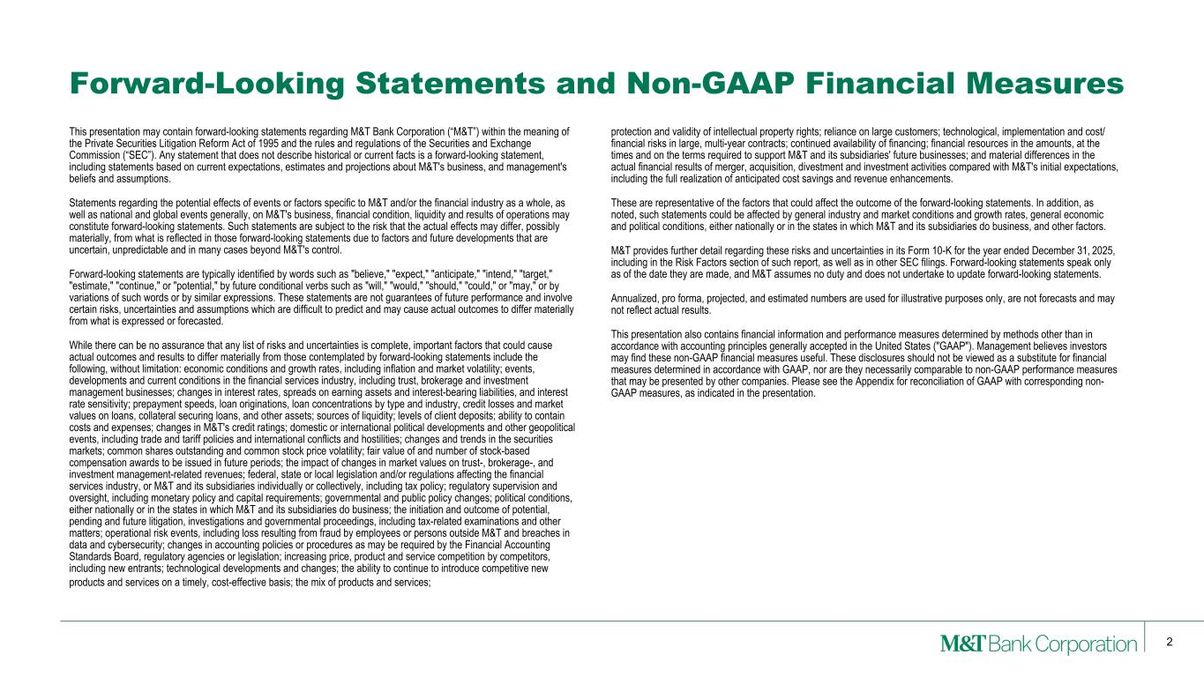
2 This presentation may contain forward-looking statements regarding M&T Bank Corporation (“M&T”) within the meaning of the Private Securities Litigation Reform Act of 1995 and the rules and regulations of the Securities and Exchange Commission (“SEC”). Any statement that does not describe historical or current facts is a forward-looking statement, including statements based on current expectations, estimates and projections about M&T's business, and management's beliefs and assumptions. Statements regarding the potential effects of events or factors specific to M&T and/or the financial industry as a whole, as well as national and global events generally, on M&T's business, financial condition, liquidity and results of operations may constitute forward-looking statements. Such statements are subject to the risk that the actual effects may differ, possibly materially, from what is reflected in those forward-looking statements due to factors and future developments that are uncertain, unpredictable and in many cases beyond M&T's control. Forward-looking statements are typically identified by words such as "believe," "expect," "anticipate," "intend," "target," "estimate," "continue," or "potential," by future conditional verbs such as "will," "would," "should," "could," or "may," or by variations of such words or by similar expressions. These statements are not guarantees of future performance and involve certain risks, uncertainties and assumptions which are difficult to predict and may cause actual outcomes to differ materially from what is expressed or forecasted. While there can be no assurance that any list of risks and uncertainties is complete, important factors that could cause actual outcomes and results to differ materially from those contemplated by forward-looking statements include the following, without limitation: economic conditions and growth rates, including inflation and market volatility; events, developments and current conditions in the financial services industry, including trust, brokerage and investment management businesses; changes in interest rates, spreads on earning assets and interest-bearing liabilities, and interest rate sensitivity; prepayment speeds, loan originations, loan concentrations by type and industry, credit losses and market values on loans, collateral securing loans, and other assets; sources of liquidity; levels of client deposits; ability to contain costs and expenses; changes in M&T's credit ratings; domestic or international political developments and other geopolitical events, including trade and tariff policies and international conflicts and hostilities; changes and trends in the securities markets; common shares outstanding and common stock price volatility; fair value of and number of stock-based compensation awards to be issued in future periods; the impact of changes in market values on trust-, brokerage-, and investment management-related revenues; federal, state or local legislation and/or regulations affecting the financial services industry, or M&T and its subsidiaries individually or collectively, including tax policy; regulatory supervision and oversight, including monetary policy and capital requirements; governmental and public policy changes; political conditions, either nationally or in the states in which M&T and its subsidiaries do business; the initiation and outcome of potential, pending and future litigation, investigations and governmental proceedings, including tax-related examinations and other matters; operational risk events, including loss resulting from fraud by employees or persons outside M&T and breaches in data and cybersecurity; changes in accounting policies or procedures as may be required by the Financial Accounting Standards Board, regulatory agencies or legislation; increasing price, product and service competition by competitors, including new entrants; technological developments and changes; the ability to continue to introduce competitive new products and services on a timely, cost-effective basis; the mix of products and services; protection and validity of intellectual property rights; reliance on large customers; technological, implementation and cost/ financial risks in large, multi-year contracts; continued availability of financing; financial resources in the amounts, at the times and on the terms required to support M&T and its subsidiaries' future businesses; and material differences in the actual financial results of merger, acquisition, divestment and investment activities compared with M&T's initial expectations, including the full realization of anticipated cost savings and revenue enhancements. These are representative of the factors that could affect the outcome of the forward-looking statements. In addition, as noted, such statements could be affected by general industry and market conditions and growth rates, general economic and political conditions, either nationally or in the states in which M&T and its subsidiaries do business, and other factors. M&T provides further detail regarding these risks and uncertainties in its Form 10-K for the year ended December 31, 2025, including in the Risk Factors section of such report, as well as in other SEC filings. Forward-looking statements speak only as of the date they are made, and M&T assumes no duty and does not undertake to update forward-looking statements. Annualized, pro forma, projected, and estimated numbers are used for illustrative purposes only, are not forecasts and may not reflect actual results. This presentation also contains financial information and performance measures determined by methods other than in accordance with accounting principles generally accepted in the United States ("GAAP"). Management believes investors may find these non-GAAP financial measures useful. These disclosures should not be viewed as a substitute for financial measures determined in accordance with GAAP, nor are they necessarily comparable to non-GAAP performance measures that may be presented by other companies. Please see the Appendix for reconciliation of GAAP with corresponding non- GAAP measures, as indicated in the presentation. Forward-Looking Statements and Non-GAAP Financial Measures

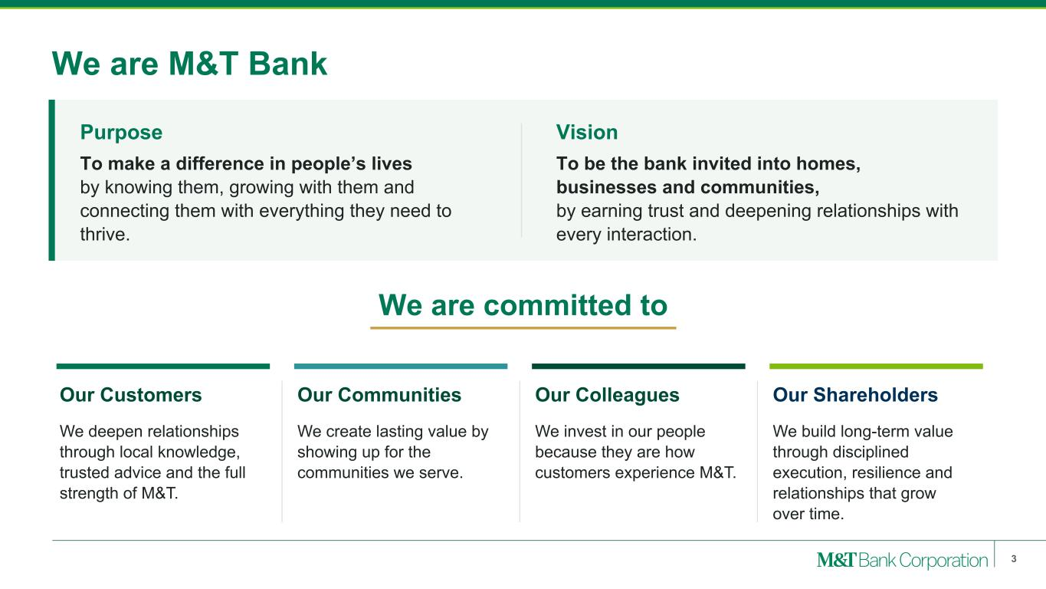
We are M&T Bank Purpose To make a difference in people’s lives by knowing them, growing with them and connecting them with everything they need to thrive. Vision To be the bank invited into homes, businesses and communities, by earning trust and deepening relationships with every interaction. We are committed to Our Customers We deepen relationships through local knowledge, trusted advice and the full strength of M&T. Our Communities We create lasting value by showing up for the communities we serve. Our Colleagues We invest in our people because they are how customers experience M&T. Our Shareholders We build long-term value through disciplined execution, resilience and relationships that grow over time. 3

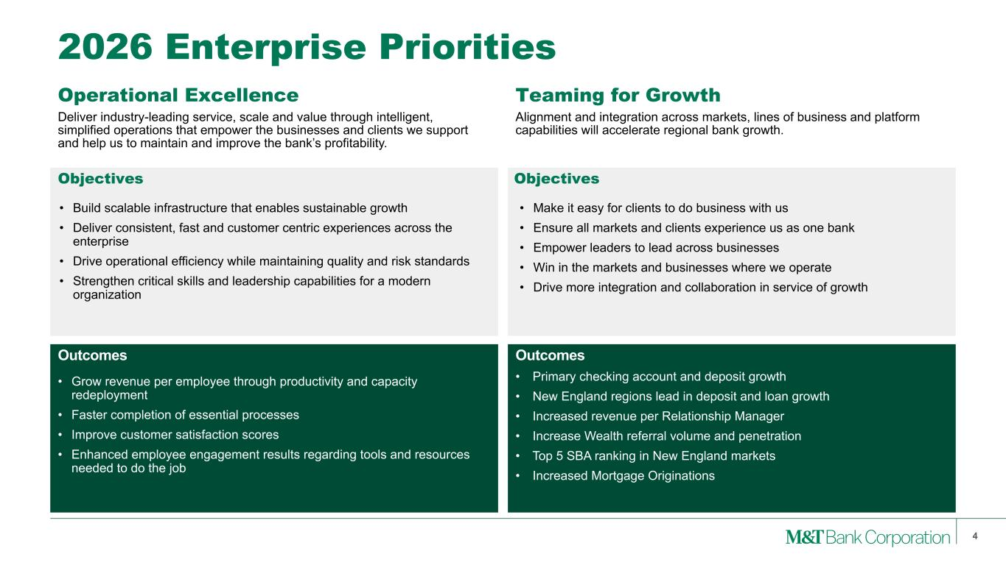
Operational Excellence Alignment and integration across markets, lines of business and platform capabilities will accelerate regional bank growth. 4 2026 Enterprise Priorities Teaming for Growth • Make it easy for clients to do business with us • Ensure all markets and clients experience us as one bank • Empower leaders to lead across businesses • Win in the markets and businesses where we operate • Drive more integration and collaboration in service of growth Deliver industry-leading service, scale and value through intelligent, simplified operations that empower the businesses and clients we support and help us to maintain and improve the bank’s profitability. • Build scalable infrastructure that enables sustainable growth • Deliver consistent, fast and customer centric experiences across the enterprise • Drive operational efficiency while maintaining quality and risk standards • Strengthen critical skills and leadership capabilities for a modern organization • Grow revenue per employee through productivity and capacity redeployment • Faster completion of essential processes • Improve customer satisfaction scores • Enhanced employee engagement results regarding tools and resources needed to do the job • Primary checking account and deposit growth • New England regions lead in deposit and loan growth • Increased revenue per Relationship Manager • Increase Wealth referral volume and penetration • Top 5 SBA ranking in New England markets • Increased Mortgage Originations Objectives Objectives Outcomes Outcomes


Key Awards and Accolades Received 13 “Best Bank” Awards across Small Business and Middle-Market Categories The Most Powerful Women in Finance: Meghan Shue, Wilmington Trust The Most Powerful Women in Banking’s Top Teams: Wilmington Trust 2025 All-America Executive Team Received #1 Ranking among Large Cap Banks and Placed in the Top 10 across All U.S. Banks Jennifer Warren, CEO, Wilmington Trust CEO of the Year Clearing & Custodial Firms Received #1 Ranking among U.S. Companies 5

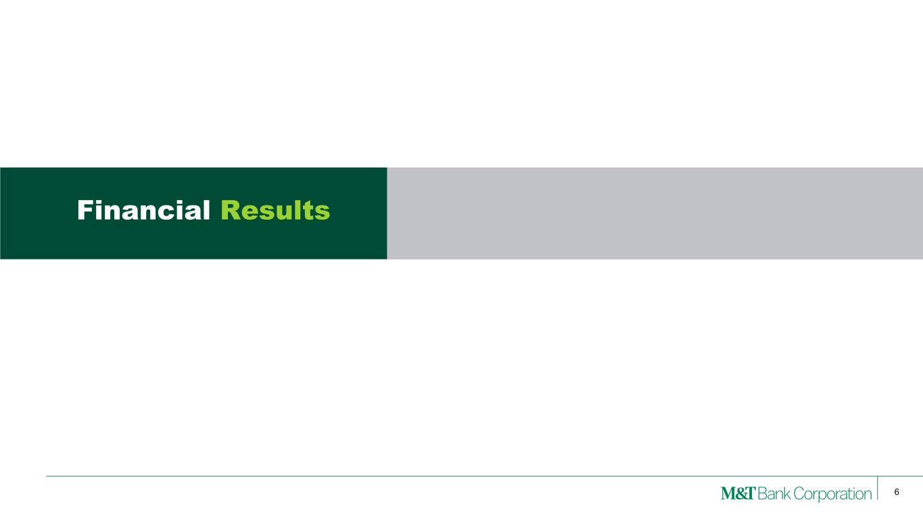
6 Financial Results

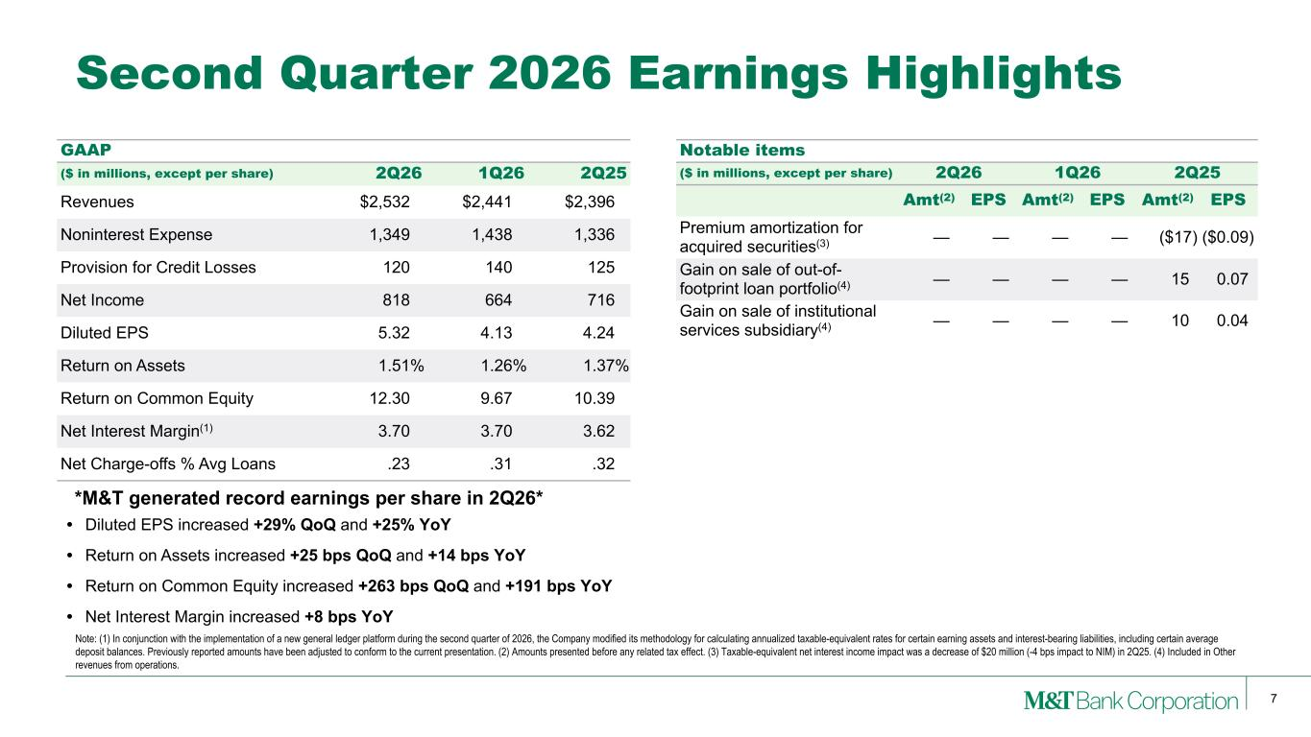
7 • Diluted EPS increased +29% QoQ and +25% YoY • Return on Assets increased +25 bps QoQ and +14 bps YoY • Return on Common Equity increased +263 bps QoQ and +191 bps YoY • Net Interest Margin increased +8 bps YoY Notable items ($ in millions, except per share) 2Q26 1Q26 2Q25 Amt(2) EPS Amt(2) EPS Amt(2) EPS Premium amortization for acquired securities(3) — — — — ($17) ($0.09) Gain on sale of out-of- footprint loan portfolio(4) — — — — 15 0.07 Gain on sale of institutional services subsidiary(4) — — — — 10 0.04 Second Quarter 2026 Earnings Highlights GAAP ($ in millions, except per share) 2Q26 1Q26 2Q25 Revenues $2,532 $2,441 $2,396 Noninterest Expense 1,349 1,438 1,336 Provision for Credit Losses 120 140 125 Net Income 818 664 716 Diluted EPS 5.32 4.13 4.24 Return on Assets 1.51% 1.26% 1.37% Return on Common Equity 12.30 9.67 10.39 Net Interest Margin(1) 3.70 3.70 3.62 Net Charge-offs % Avg Loans .23 .31 .32 Note: (1) In conjunction with the implementation of a new general ledger platform during the second quarter of 2026, the Company modified its methodology for calculating annualized taxable-equivalent rates for certain earning assets and interest-bearing liabilities, including certain average deposit balances. Previously reported amounts have been adjusted to conform to the current presentation. (2) Amounts presented before any related tax effect. (3) Taxable-equivalent net interest income impact was a decrease of $20 million (-4 bps impact to NIM) in 2Q25. (4) Included in Other revenues from operations. *M&T generated record earnings per share in 2Q26*

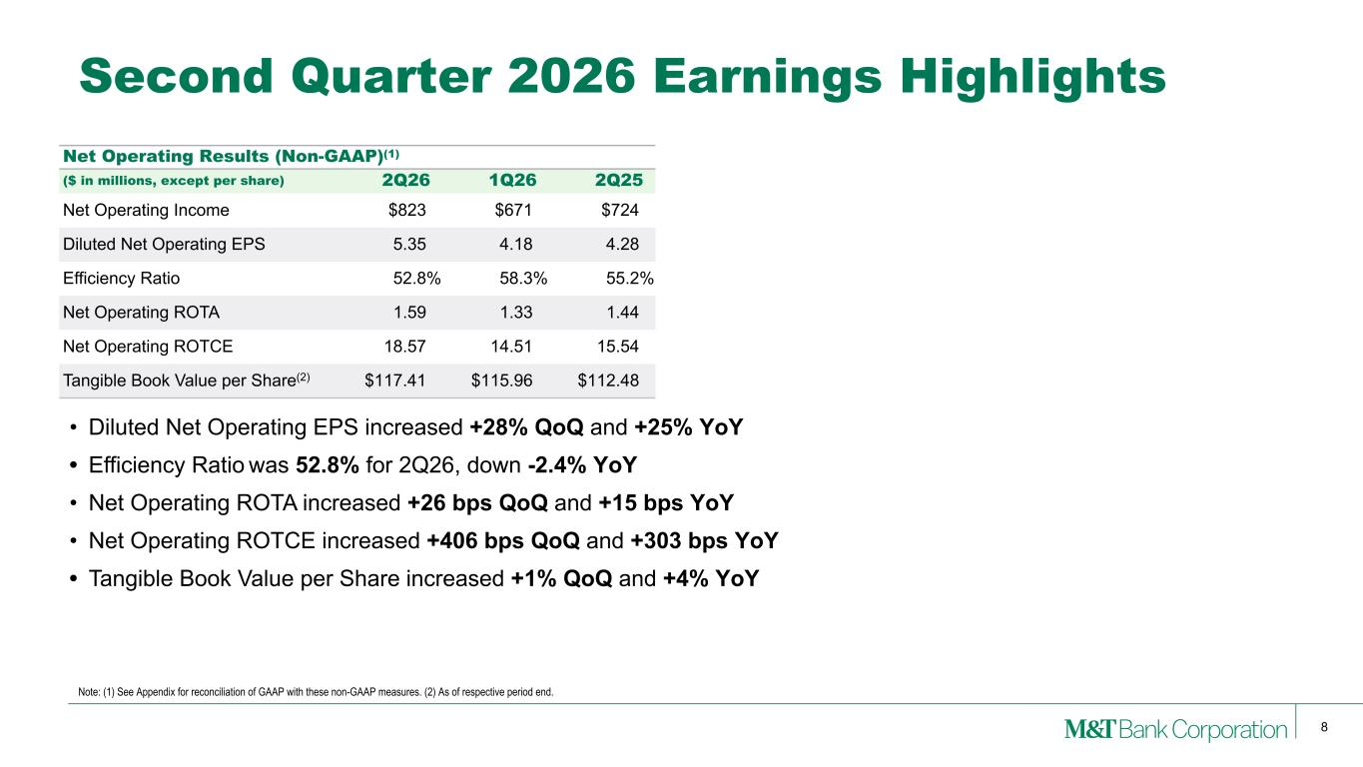
8 Note: (1) See Appendix for reconciliation of GAAP with these non-GAAP measures. (2) As of respective period end. Second Quarter 2026 Earnings Highlights Net Operating Results (Non-GAAP)(1) ($ in millions, except per share) 2Q26 1Q26 2Q25 Net Operating Income $823 $671 $724 Diluted Net Operating EPS 5.35 4.18 4.28 Efficiency Ratio 52.8% 58.3% 55.2% Net Operating ROTA 1.59 1.33 1.44 Net Operating ROTCE 18.57 14.51 15.54 Tangible Book Value per Share(2) $117.41 $115.96 $112.48 • Diluted Net Operating EPS increased +28% QoQ and +25% YoY • Efficiency Ratio was 52.8% for 2Q26, down -2.4% YoY • Net Operating ROTA increased +26 bps QoQ and +15 bps YoY • Net Operating ROTCE increased +406 bps QoQ and +303 bps YoY • Tangible Book Value per Share increased +1% QoQ and +4% YoY

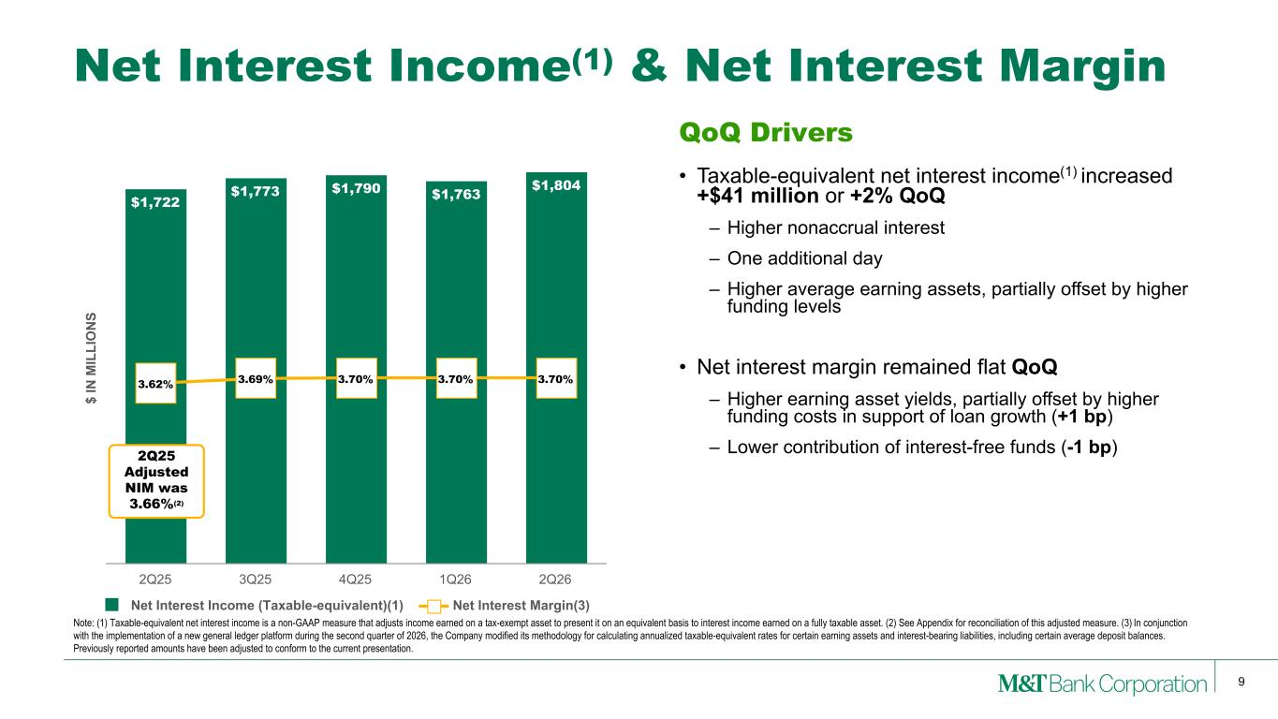
9 Net Interest Income(1) & Net Interest Margin Note: (1) Taxable-equivalent net interest income is a non-GAAP measure that adjusts income earned on a tax-exempt asset to present it on an equivalent basis to interest income earned on a fully taxable asset. (2) See Appendix for reconciliation of this adjusted measure. (3) In conjunction with the implementation of a new general ledger platform during the second quarter of 2026, the Company modified its methodology for calculating annualized taxable-equivalent rates for certain earning assets and interest-bearing liabilities, including certain average deposit balances. Previously reported amounts have been adjusted to conform to the current presentation. $ IN M IL LI O N S $1,722 $1,773 $1,790 $1,763 $1,804 3.62% 3.69% 3.70% 3.70% 3.70% Net Interest Income (Taxable-equivalent)(1) Net Interest Margin(3) 2Q25 3Q25 4Q25 1Q26 2Q26 QoQ Drivers • Taxable-equivalent net interest income(1) increased +$41 million or +2% QoQ – Higher nonaccrual interest – One additional day – Higher average earning assets, partially offset by higher funding levels • Net interest margin remained flat QoQ – Higher earning asset yields, partially offset by higher funding costs in support of loan growth (+1 bp) – Lower contribution of interest-free funds (-1 bp)2Q25 Adjusted NIM was 3.66%(2)

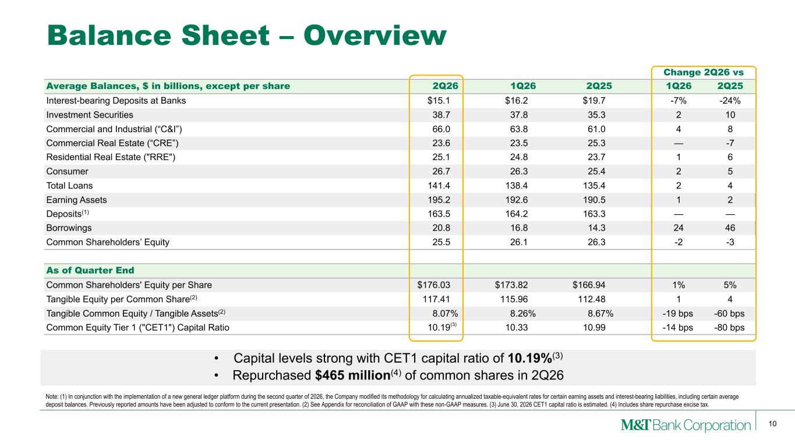
10 • Capital levels strong with CET1 capital ratio of 10.19%(3) • Repurchased $465 million(4) of common shares in 2Q26 Change 2Q26 vs Average Balances, $ in billions, except per share 2Q26 1Q26 2Q25 1Q26 2Q25 Interest-bearing Deposits at Banks $15.1 $16.2 $19.7 -7% -24% Investment Securities 38.7 37.8 35.3 2 10 Commercial and Industrial (“C&I”) 66.0 63.8 61.0 4 8 Commercial Real Estate (“CRE”) 23.6 23.5 25.3 — -7 Residential Real Estate ("RRE") 25.1 24.8 23.7 1 6 Consumer 26.7 26.3 25.4 2 5 Total Loans 141.4 138.4 135.4 2 4 Earning Assets 195.2 192.6 190.5 1 2 Deposits(1) 163.5 164.2 163.3 — — Borrowings 20.8 16.8 14.3 24 46 Common Shareholders’ Equity 25.5 26.1 26.3 -2 -3 As of Quarter End Common Shareholders' Equity per Share $176.03 $173.82 $166.94 1% 5% Tangible Equity per Common Share(2) 117.41 115.96 112.48 1 4 Tangible Common Equity / Tangible Assets(2) 8.07 % 8.26 % 8.67 % -19 bps -60 bps Common Equity Tier 1 ("CET1") Capital Ratio 10.19 10.33 10.99 -14 bps -80 bps Balance Sheet – Overview Note: (1) In conjunction with the implementation of a new general ledger platform during the second quarter of 2026, the Company modified its methodology for calculating annualized taxable-equivalent rates for certain earning assets and interest-bearing liabilities, including certain average deposit balances. Previously reported amounts have been adjusted to conform to the current presentation. (2) See Appendix for reconciliation of GAAP with these non-GAAP measures. (3) June 30, 2026 CET1 capital ratio is estimated. (4) Includes share repurchase excise tax. (3)

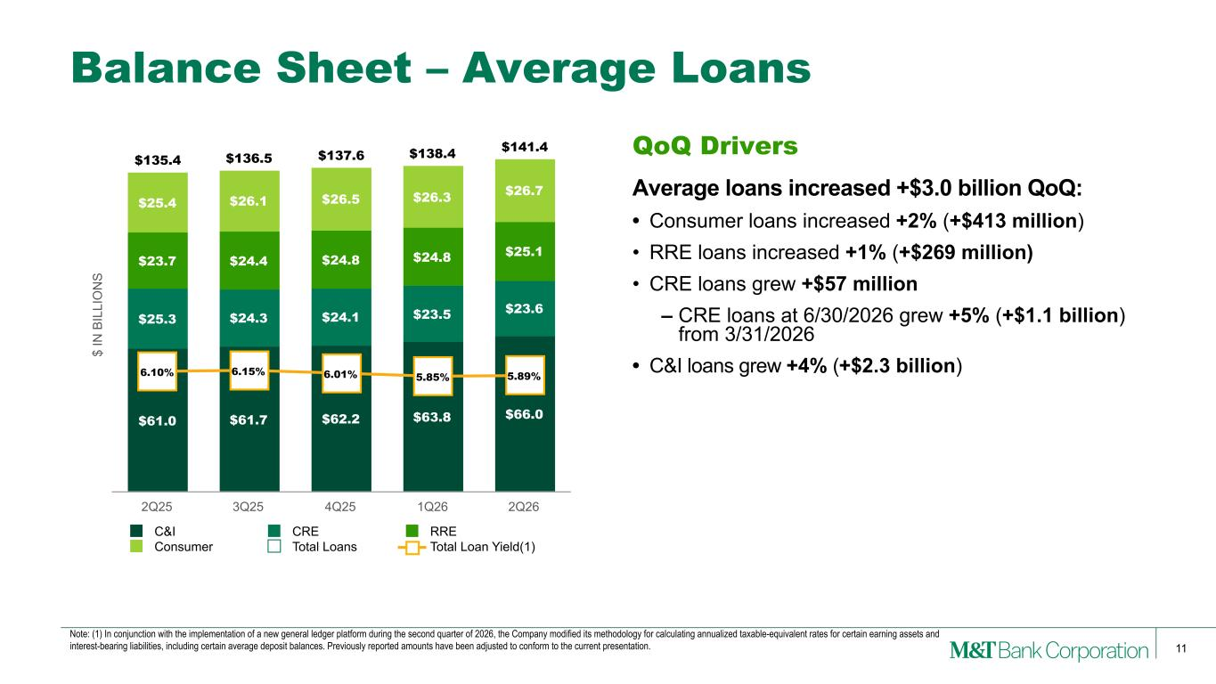
11 Balance Sheet – Average Loans QoQ Drivers Average loans increased +$3.0 billion QoQ: • Consumer loans increased +2% (+$413 million) • RRE loans increased +1% (+$269 million) • CRE loans grew +$57 million – CRE loans at 6/30/2026 grew +5% (+$1.1 billion) from 3/31/2026 • C&I loans grew +4% (+$2.3 billion) $ IN B IL LI O N S $61.0 $61.7 $62.2 $63.8 $66.0 $25.3 $24.3 $24.1 $23.5 $23.6 $23.7 $24.4 $24.8 $24.8 $25.1 $25.4 $26.1 $26.5 $26.3 $26.7 $135.4 $136.5 $137.6 $138.4 $141.4 6.10% 6.15% 6.01% 5.85% 5.89% C&I CRE RRE Consumer Total Loans Total Loan Yield(1) 2Q25 3Q25 4Q25 1Q26 2Q26 Note: (1) In conjunction with the implementation of a new general ledger platform during the second quarter of 2026, the Company modified its methodology for calculating annualized taxable-equivalent rates for certain earning assets and interest-bearing liabilities, including certain average deposit balances. Previously reported amounts have been adjusted to conform to the current presentation.

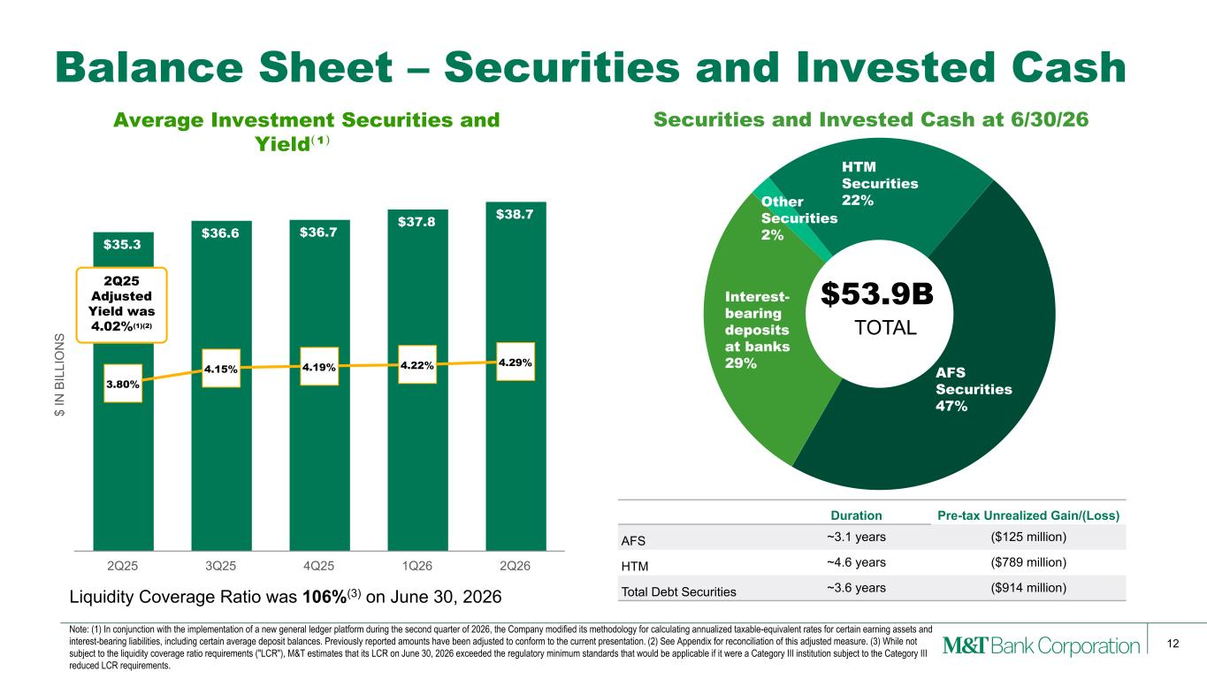
12 Balance Sheet – Securities and Invested Cash Liquidity Coverage Ratio was 106%(3) on June 30, 2026 Duration Pre-tax Unrealized Gain/(Loss) AFS ~3.1 years ($125 million) HTM ~4.6 years ($789 million) Total Debt Securities ~3.6 years ($914 million) $ IN B IL LI O N S Average Investment Securities and Yield⁽¹⁾ $35.3 $36.6 $36.7 $37.8 $38.7 3.80% 4.15% 4.19% 4.22% 4.29% 2Q25 3Q25 4Q25 1Q26 2Q26 Interest- bearing deposits at banks 29% Other Securities 2% HTM Securities 22% AFS Securities 47% $53.9B TOTAL 2Q25 Adjusted Yield was 4.02%(1)(2) Securities and Invested Cash at 6/30/26 Note: (1) In conjunction with the implementation of a new general ledger platform during the second quarter of 2026, the Company modified its methodology for calculating annualized taxable-equivalent rates for certain earning assets and interest-bearing liabilities, including certain average deposit balances. Previously reported amounts have been adjusted to conform to the current presentation. (2) See Appendix for reconciliation of this adjusted measure. (3) While not subject to the liquidity coverage ratio requirements ("LCR"), M&T estimates that its LCR on June 30, 2026 exceeded the regulatory minimum standards that would be applicable if it were a Category III institution subject to the Category III reduced LCR requirements.

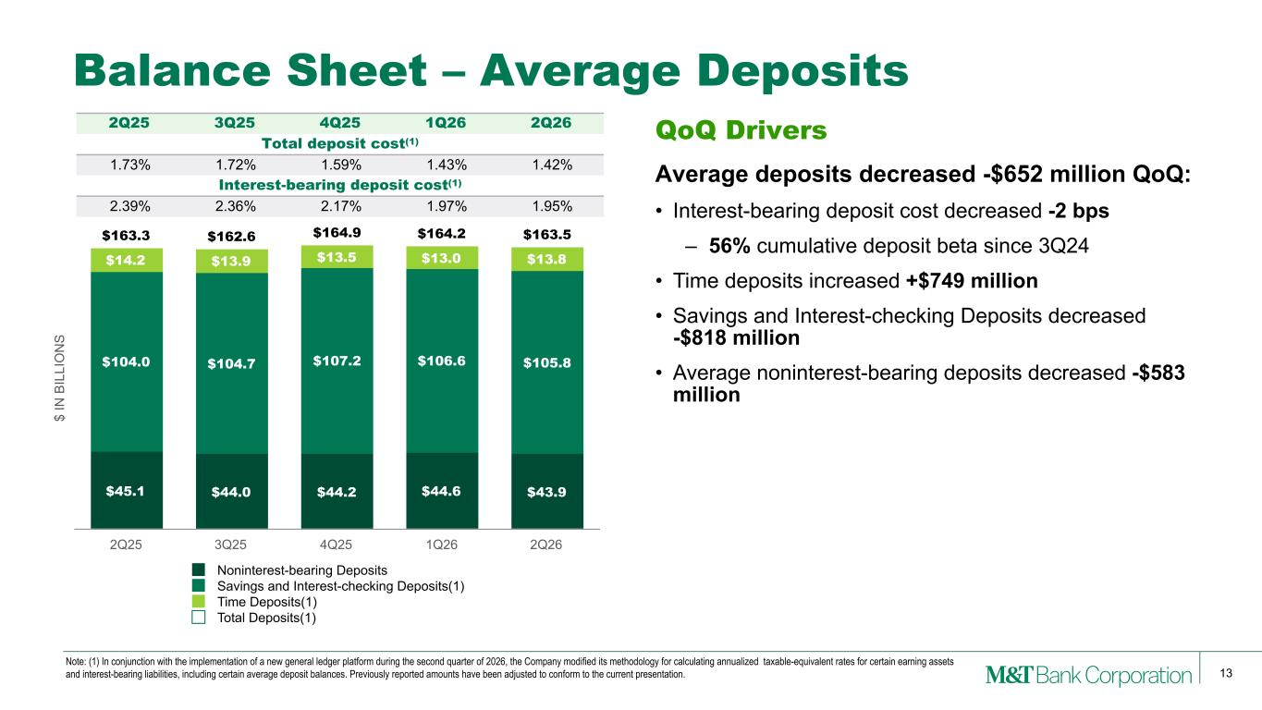
13 Balance Sheet – Average Deposits QoQ Drivers Average deposits decreased -$652 million QoQ: • Interest-bearing deposit cost decreased -2 bps – 56% cumulative deposit beta since 3Q24 • Time deposits increased +$749 million • Savings and Interest-checking Deposits decreased -$818 million • Average noninterest-bearing deposits decreased -$583 million $ IN B IL LI O N S $45.1 $44.0 $44.2 $44.6 $43.9 $104.0 $104.7 $107.2 $106.6 $105.8 $14.2 $13.9 $13.5 $13.0 $13.8 $163.3 $162.6 $164.9 $164.2 $163.5 Noninterest-bearing Deposits Savings and Interest-checking Deposits(1) Time Deposits(1) Total Deposits(1) 2Q25 3Q25 4Q25 1Q26 2Q26 2Q25 3Q25 4Q25 1Q26 2Q26 Total deposit cost(1) 1.73% 1.72% 1.59% 1.43% 1.42% Interest-bearing deposit cost(1) 2.39% 2.36% 2.17% 1.97% 1.95% Note: (1) In conjunction with the implementation of a new general ledger platform during the second quarter of 2026, the Company modified its methodology for calculating annualized taxable-equivalent rates for certain earning assets and interest-bearing liabilities, including certain average deposit balances. Previously reported amounts have been adjusted to conform to the current presentation.

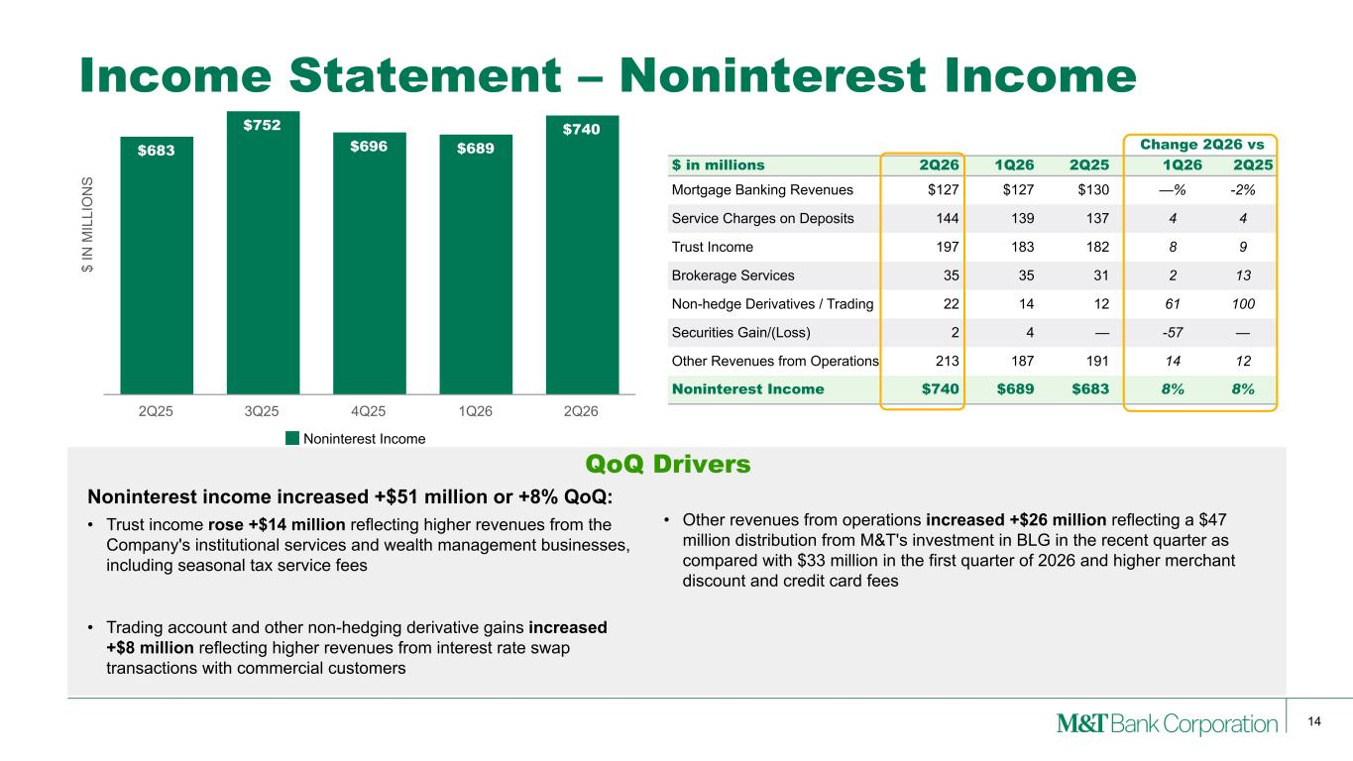
14 $ IN M IL LI O N S $683 $752 $696 $689 $740 Noninterest Income 2Q25 3Q25 4Q25 1Q26 2Q26 Change 2Q26 vs $ in millions 2Q26 1Q26 2Q25 1Q26 2Q25 Mortgage Banking Revenues $127 $127 $130 —% -2% Service Charges on Deposits 144 139 137 4 4 Trust Income 197 183 182 8 9 Brokerage Services 35 35 31 2 13 Non-hedge Derivatives / Trading 22 14 12 61 100 Securities Gain/(Loss) 2 4 — -57 — Other Revenues from Operations 213 187 191 14 12 Noninterest Income $740 $689 $683 8% 8% Income Statement – Noninterest Income Noninterest income increased +$51 million or +8% QoQ: • Trust income rose +$14 million reflecting higher revenues from the Company's institutional services and wealth management businesses, including seasonal tax service fees • Trading account and other non-hedging derivative gains increased +$8 million reflecting higher revenues from interest rate swap transactions with commercial customers • Other revenues from operations increased +$26 million reflecting a $47 million distribution from M&T's investment in BLG in the recent quarter as compared with $33 million in the first quarter of 2026 and higher merchant discount and credit card fees QoQ Drivers

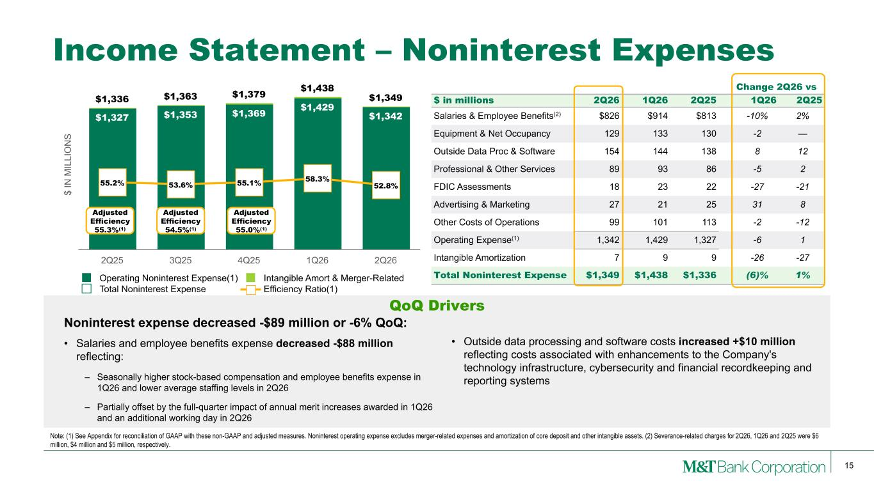
15 $ IN M IL LI O N S $1,327 $1,353 $1,369 $1,429 $1,342 $1,336 $1,363 $1,379 $1,438 $1,349 55.2% 53.6% 55.1% 58.3% 52.8% Operating Noninterest Expense(1) Intangible Amort & Merger-Related Total Noninterest Expense Efficiency Ratio(1) 2Q25 3Q25 4Q25 1Q26 2Q26 Change 2Q26 vs $ in millions 2Q26 1Q26 2Q25 1Q26 2Q25 Salaries & Employee Benefits(2) $826 $914 $813 -10% 2% Equipment & Net Occupancy 129 133 130 -2 — Outside Data Proc & Software 154 144 138 8 12 Professional & Other Services 89 93 86 -5 2 FDIC Assessments 18 23 22 -27 -21 Advertising & Marketing 27 21 25 31 8 Other Costs of Operations 99 101 113 -2 -12 Operating Expense(1) 1,342 1,429 1,327 -6 1 Intangible Amortization 7 9 9 -26 -27 Total Noninterest Expense $1,349 $1,438 $1,336 (6)% 1% Income Statement – Noninterest Expenses Noninterest expense decreased -$89 million or -6% QoQ: • Salaries and employee benefits expense decreased -$88 million reflecting: – Seasonally higher stock-based compensation and employee benefits expense in 1Q26 and lower average staffing levels in 2Q26 – Partially offset by the full-quarter impact of annual merit increases awarded in 1Q26 and an additional working day in 2Q26 Note: (1) See Appendix for reconciliation of GAAP with these non-GAAP and adjusted measures. Noninterest operating expense excludes merger-related expenses and amortization of core deposit and other intangible assets. (2) Severance-related charges for 2Q26, 1Q26 and 2Q25 were $6 million, $4 million and $5 million, respectively. QoQ Drivers Adjusted Efficiency 54.5%(1) Adjusted Efficiency 55.3%(1) Adjusted Efficiency 55.0%(1) • Outside data processing and software costs increased +$10 million reflecting costs associated with enhancements to the Company's technology infrastructure, cybersecurity and financial recordkeeping and reporting systems

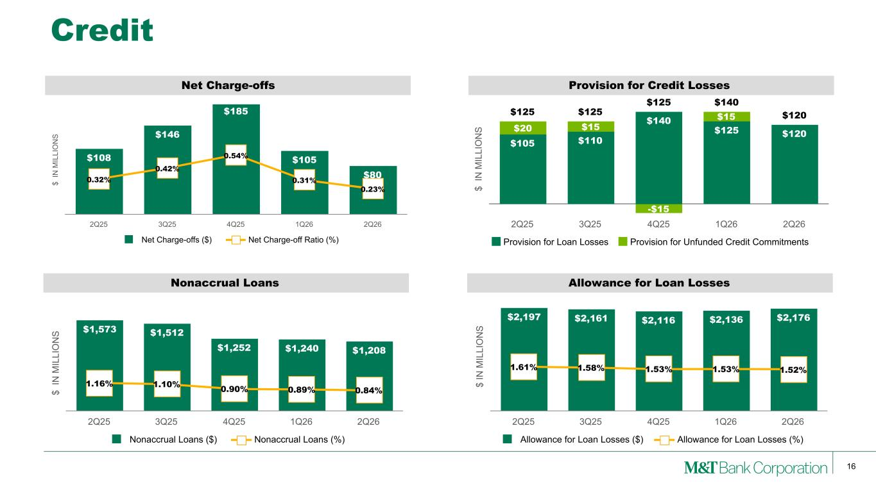
16 $ IN M IL LI O N S Nonaccrual Loans $1,573 $1,512 $1,252 $1,240 $1,208 1.16% 1.10% 0.90% 0.89% 0.84% Nonaccrual Loans ($) Nonaccrual Loans (%) 2Q25 3Q25 4Q25 1Q26 2Q26 $ IN M IL LI O N S Net Charge-offs $108 $146 $185 $105 $800.32% 0.42% 0.54% 0.31% 0.23% Net Charge-offs ($) Net Charge-off Ratio (%) 2Q25 3Q25 4Q25 1Q26 2Q26 Credit $ IN M IL LI O N S Allowance for Loan Losses $2,197 $2,161 $2,116 $2,136 $2,176 1.61% 1.58% 1.53% 1.53% 1.52% Allowance for Loan Losses ($) Allowance for Loan Losses (%) 2Q25 3Q25 4Q25 1Q26 2Q26 $ IN M IL LI O N S Provision for Credit Losses $125 $125 $125 $140 $120 $105 $110 $140 $125 $120$20 $15 -$15 $15 Provision for Loan Losses Provision for Unfunded Credit Commitments 2Q25 3Q25 4Q25 1Q26 2Q26

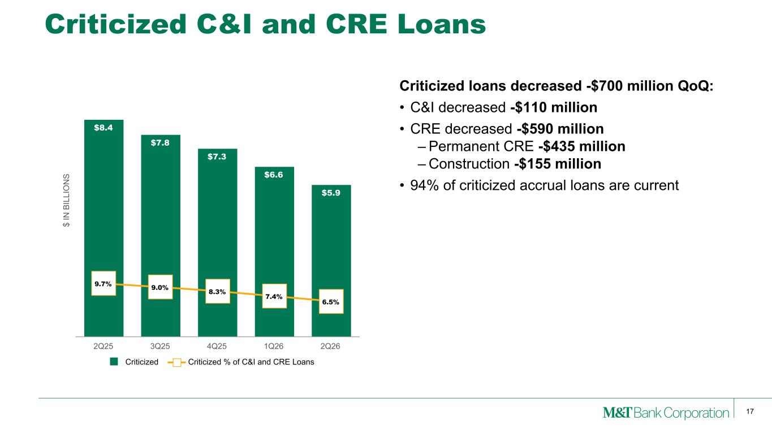
17 Criticized C&I and CRE Loans Criticized loans decreased -$700 million QoQ: • C&I decreased -$110 million • CRE decreased -$590 million – Permanent CRE -$435 million – Construction -$155 million • 94% of criticized accrual loans are current $ IN B IL LI O N S $8.4 $7.8 $7.3 $6.6 $5.9 9.7% 9.0% 8.3% 7.4% 6.5% Criticized Criticized % of C&I and CRE Loans 2Q25 3Q25 4Q25 1Q26 2Q26

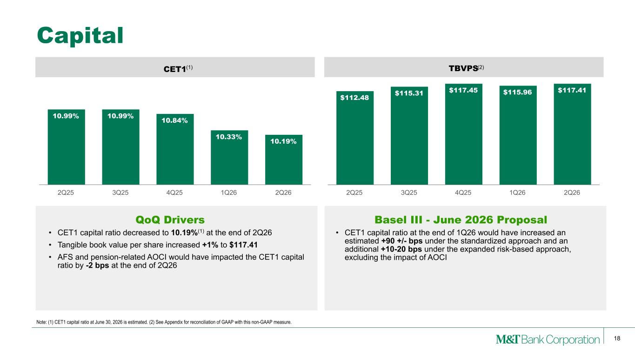
18 CET1 10.99% 10.99% 10.84% 10.33% 10.19% 2Q25 3Q25 4Q25 1Q26 2Q26 TBVPS $112.48 $115.31 $117.45 $115.96 $117.41 2Q25 3Q25 4Q25 1Q26 2Q26 Capital • CET1 capital ratio decreased to 10.19%(1) at the end of 2Q26 • Tangible book value per share increased +1% to $117.41 • AFS and pension-related AOCI would have impacted the CET1 capital ratio by -2 bps at the end of 2Q26 Note: (1) CET1 capital ratio at June 30, 2026 is estimated. (2) See Appendix for reconciliation of GAAP with this non-GAAP measure. QoQ Drivers (1) (2) Basel III - June 2026 Proposal • CET1 capital ratio at the end of 1Q26 would have increased an estimated +90 +/- bps under the standardized approach and an additional +10-20 bps under the expanded risk-based approach, excluding the impact of AOCI

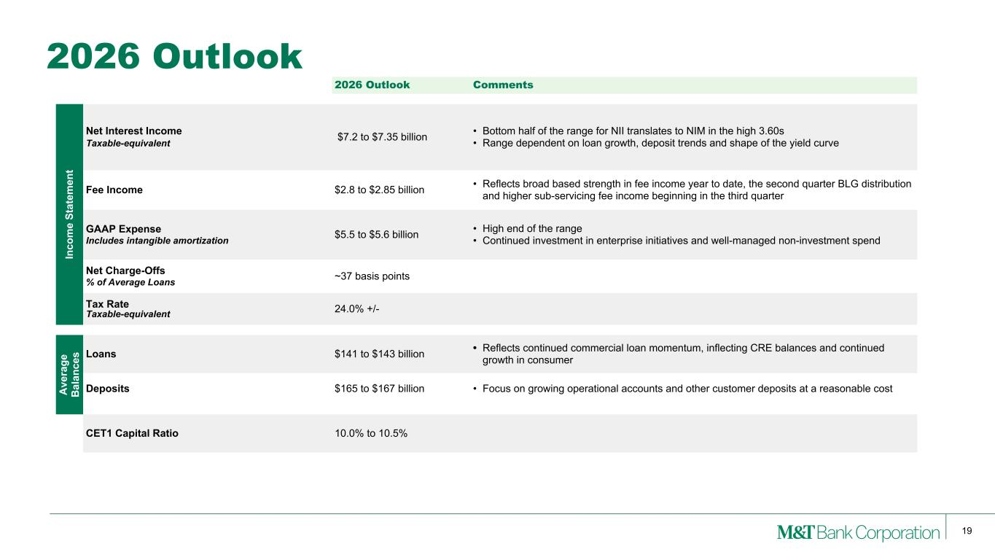
19 2026 Outlook 2026 Outlook Comments In co m e St at em en t Net Interest Income Taxable-equivalent $7.2 to $7.35 billion • Bottom half of the range for NII translates to NIM in the high 3.60s • Range dependent on loan growth, deposit trends and shape of the yield curve Fee Income $2.8 to $2.85 billion • Reflects broad based strength in fee income year to date, the second quarter BLG distribution and higher sub-servicing fee income beginning in the third quarter GAAP Expense Includes intangible amortization $5.5 to $5.6 billion • High end of the range • Continued investment in enterprise initiatives and well-managed non-investment spend Net Charge-Offs % of Average Loans ~37 basis points Tax Rate Taxable-equivalent 24.0% +/- A ve ra ge B al an ce s Loans $141 to $143 billion • Reflects continued commercial loan momentum, inflecting CRE balances and continued growth in consumer Deposits $165 to $167 billion • Focus on growing operational accounts and other customer deposits at a reasonable cost CET1 Capital Ratio 10.0% to 10.5%

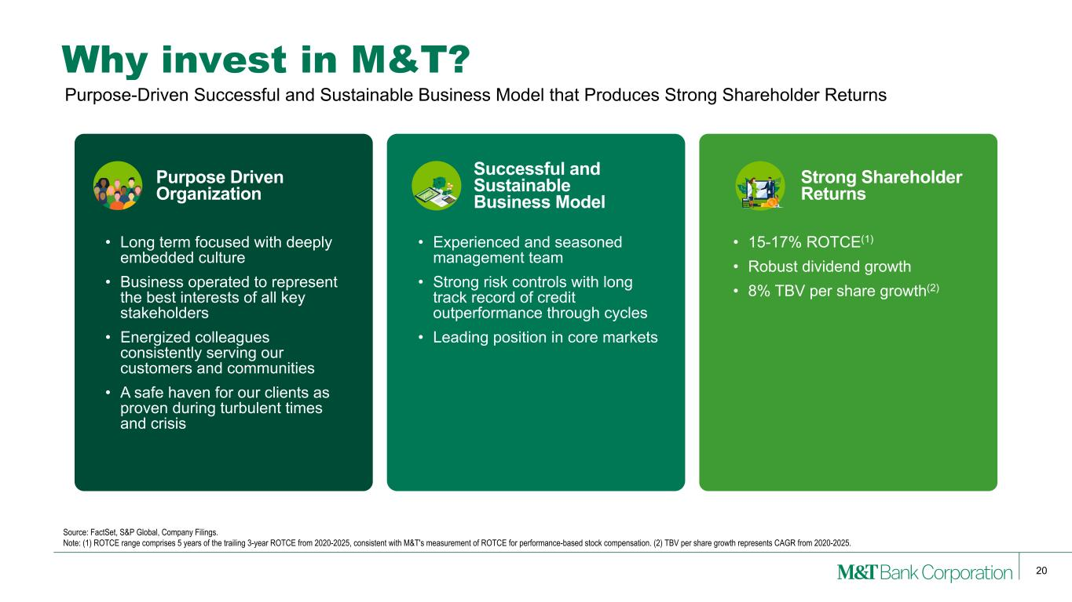
20 Why invest in M&T? • Long term focused with deeply embedded culture • Business operated to represent the best interests of all key stakeholders • Energized colleagues consistently serving our customers and communities • A safe haven for our clients as proven during turbulent times and crisis • Experienced and seasoned management team • Strong risk controls with long track record of credit outperformance through cycles • Leading position in core markets • 15-17% ROTCE(1) • Robust dividend growth • 8% TBV per share growth(2) Source: FactSet, S&P Global, Company Filings. Note: (1) ROTCE range comprises 5 years of the trailing 3-year ROTCE from 2020-2025, consistent with M&T's measurement of ROTCE for performance-based stock compensation. (2) TBV per share growth represents CAGR from 2020-2025. Purpose-Driven Successful and Sustainable Business Model that Produces Strong Shareholder Returns Purpose Driven Organization Successful and Sustainable Business Model Strong Shareholder Returns

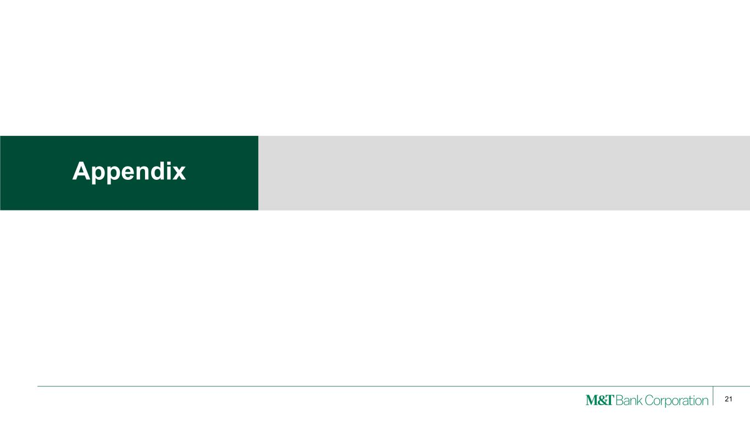
21 Appendix

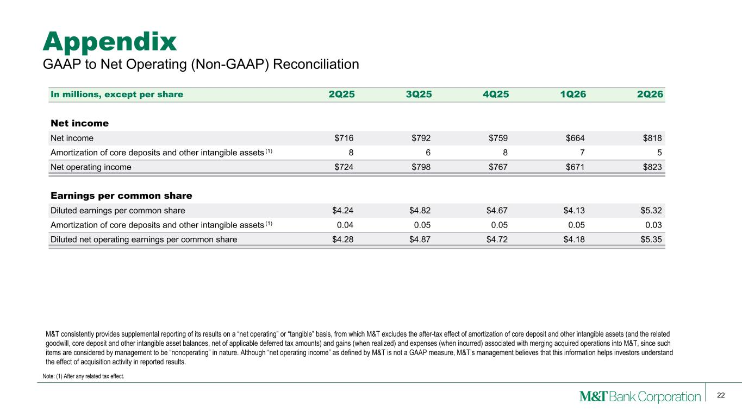
22 M&T consistently provides supplemental reporting of its results on a “net operating” or “tangible” basis, from which M&T excludes the after-tax effect of amortization of core deposit and other intangible assets (and the related goodwill, core deposit and other intangible asset balances, net of applicable deferred tax amounts) and gains (when realized) and expenses (when incurred) associated with merging acquired operations into M&T, since such items are considered by management to be “nonoperating” in nature. Although “net operating income” as defined by M&T is not a GAAP measure, M&T’s management believes that this information helps investors understand the effect of acquisition activity in reported results. Appendix Note: (1) After any related tax effect. GAAP to Net Operating (Non-GAAP) Reconciliation In millions, except per share 2Q25 3Q25 4Q25 1Q26 2Q26 Net income Net income $716 $792 $759 $664 $818 Amortization of core deposits and other intangible assets (1) 8 6 8 7 5 Net operating income $724 $798 $767 $671 $823 Earnings per common share Diluted earnings per common share $4.24 $4.82 $4.67 $4.13 $5.32 Amortization of core deposits and other intangible assets (1) 0.04 0.05 0.05 0.05 0.03 Diluted net operating earnings per common share $4.28 $4.87 $4.72 $4.18 $5.35

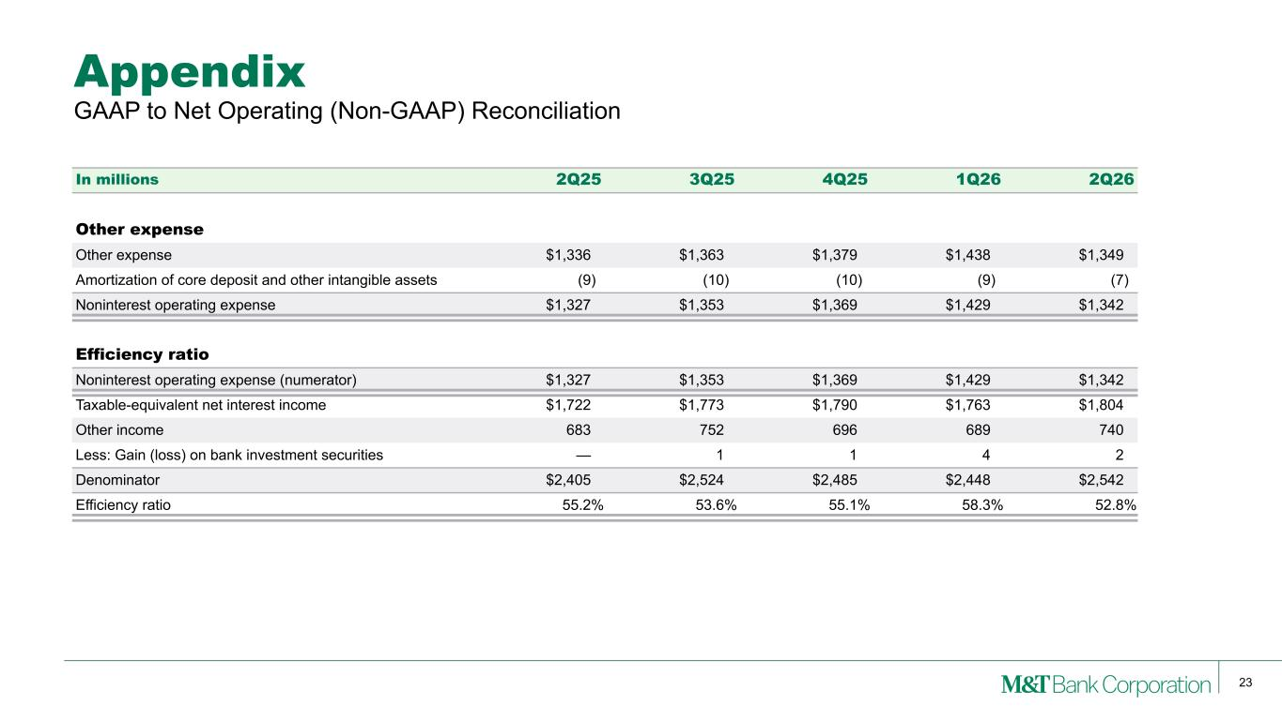
23 Appendix GAAP to Net Operating (Non-GAAP) Reconciliation In millions 2Q25 3Q25 4Q25 1Q26 2Q26 Other expense Other expense $1,336 $1,363 $1,379 $1,438 $1,349 Amortization of core deposit and other intangible assets (9) (10) (10) (9) (7) Noninterest operating expense $1,327 $1,353 $1,369 $1,429 $1,342 Efficiency ratio Noninterest operating expense (numerator) $1,327 $1,353 $1,369 $1,429 $1,342 Taxable-equivalent net interest income $1,722 $1,773 $1,790 $1,763 $1,804 Other income 683 752 696 689 740 Less: Gain (loss) on bank investment securities — 1 1 4 2 Denominator $2,405 $2,524 $2,485 $2,448 $2,542 Efficiency ratio 55.2 % 53.6 % 55.1 % 58.3 % 52.8 %

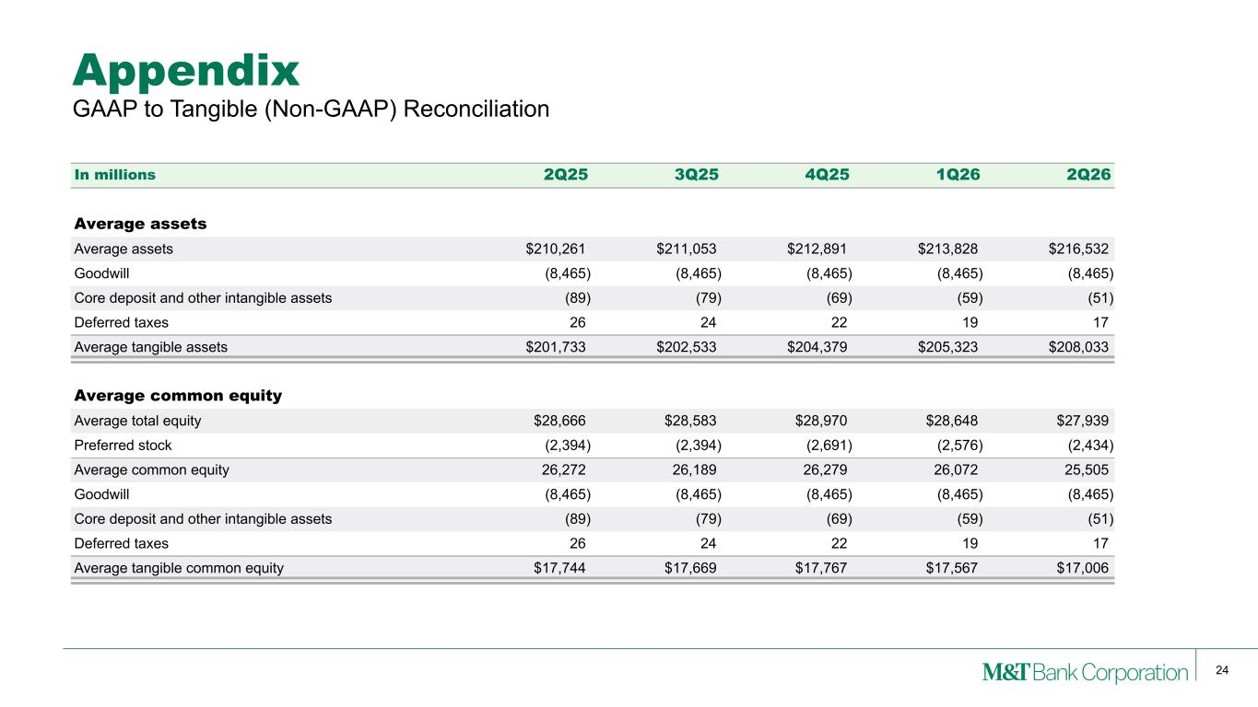
24 Appendix In millions 2Q25 3Q25 4Q25 1Q26 2Q26 Average assets Average assets $210,261 $211,053 $212,891 $213,828 $216,532 Goodwill (8,465) (8,465) (8,465) (8,465) (8,465) Core deposit and other intangible assets (89) (79) (69) (59) (51) Deferred taxes 26 24 22 19 17 Average tangible assets $201,733 $202,533 $204,379 $205,323 $208,033 Average common equity Average total equity $28,666 $28,583 $28,970 $28,648 $27,939 Preferred stock (2,394) (2,394) (2,691) (2,576) (2,434) Average common equity 26,272 26,189 26,279 26,072 25,505 Goodwill (8,465) (8,465) (8,465) (8,465) (8,465) Core deposit and other intangible assets (89) (79) (69) (59) (51) Deferred taxes 26 24 22 19 17 Average tangible common equity $17,744 $17,669 $17,767 $17,567 $17,006 GAAP to Tangible (Non-GAAP) Reconciliation

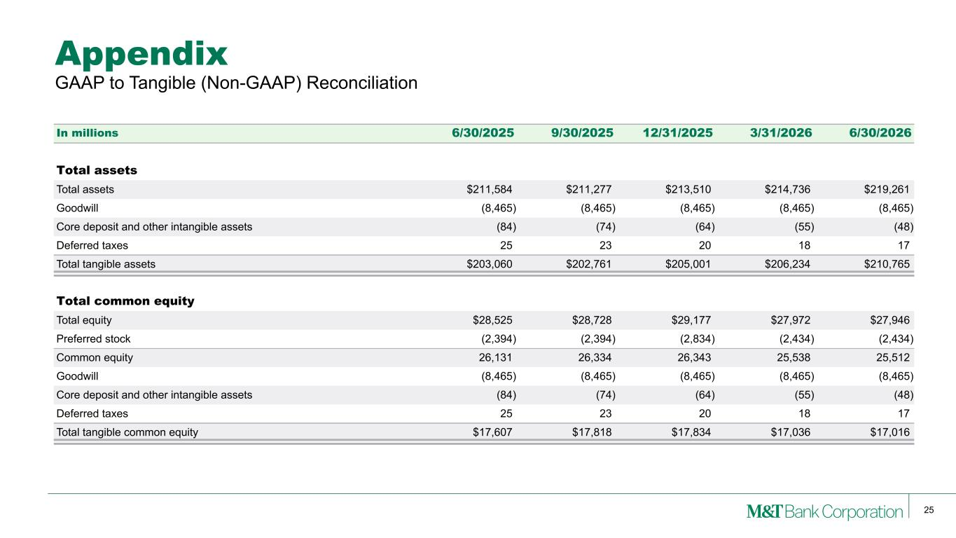
25 Appendix In millions 6/30/2025 9/30/2025 12/31/2025 3/31/2026 6/30/2026 Total assets Total assets $211,584 $211,277 $213,510 $214,736 $219,261 Goodwill (8,465) (8,465) (8,465) (8,465) (8,465) Core deposit and other intangible assets (84) (74) (64) (55) (48) Deferred taxes 25 23 20 18 17 Total tangible assets $203,060 $202,761 $205,001 $206,234 $210,765 Total common equity Total equity $28,525 $28,728 $29,177 $27,972 $27,946 Preferred stock (2,394) (2,394) (2,834) (2,434) (2,434) Common equity 26,131 26,334 26,343 25,538 25,512 Goodwill (8,465) (8,465) (8,465) (8,465) (8,465) Core deposit and other intangible assets (84) (74) (64) (55) (48) Deferred taxes 25 23 20 18 17 Total tangible common equity $17,607 $17,818 $17,834 $17,036 $17,016 GAAP to Tangible (Non-GAAP) Reconciliation

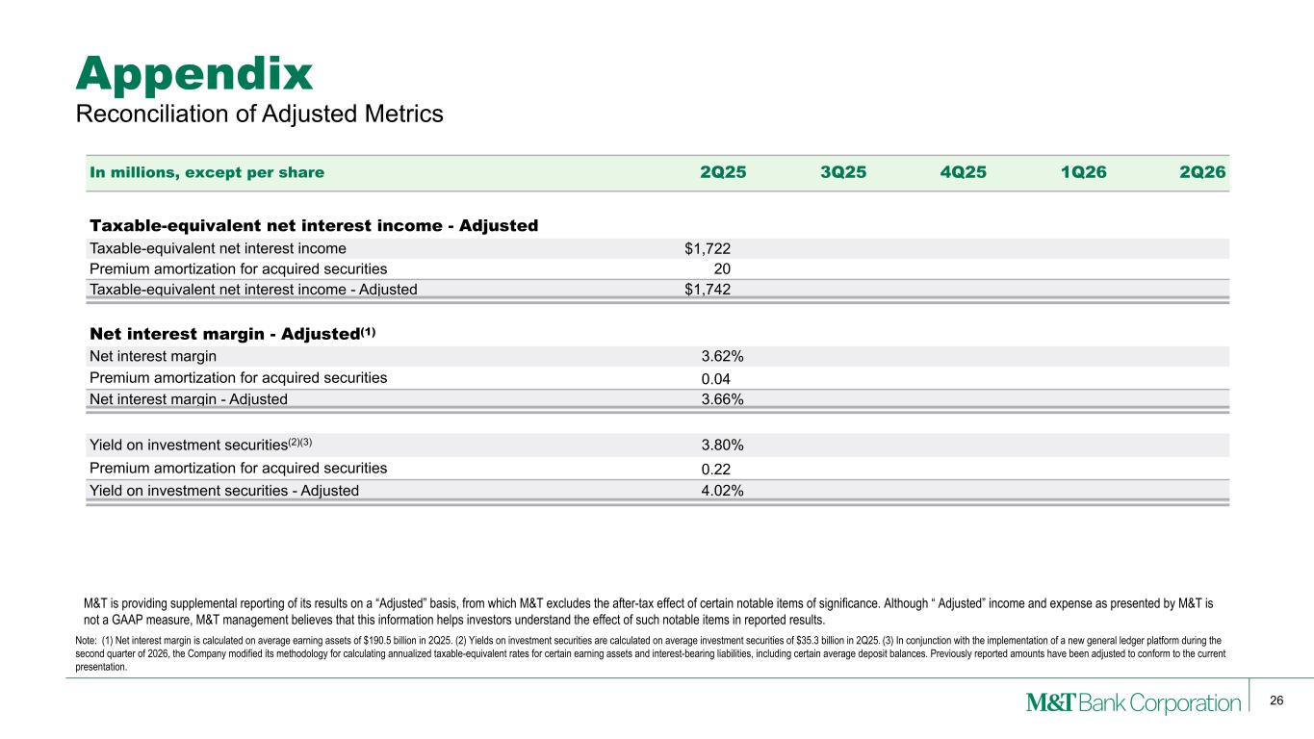
26 Appendix Reconciliation of Adjusted Metrics In millions, except per share 2Q25 3Q25 4Q25 1Q26 2Q26 Taxable-equivalent net interest income - Adjusted Taxable-equivalent net interest income $1,722 Premium amortization for acquired securities 20 Taxable-equivalent net interest income - Adjusted $1,742 Net interest margin - Adjusted(1) Net interest margin 3.62% Premium amortization for acquired securities 0.04 Net interest margin - Adjusted 3.66% Yield on investment securities(2)(3) 3.80% Premium amortization for acquired securities 0.22 Yield on investment securities - Adjusted 4.02% Note: (1) Net interest margin is calculated on average earning assets of $190.5 billion in 2Q25. (2) Yields on investment securities are calculated on average investment securities of $35.3 billion in 2Q25. (3) In conjunction with the implementation of a new general ledger platform during the second quarter of 2026, the Company modified its methodology for calculating annualized taxable-equivalent rates for certain earning assets and interest-bearing liabilities, including certain average deposit balances. Previously reported amounts have been adjusted to conform to the current presentation. M&T is providing supplemental reporting of its results on a “Adjusted” basis, from which M&T excludes the after-tax effect of certain notable items of significance. Although “ Adjusted” income and expense as presented by M&T is not a GAAP measure, M&T management believes that this information helps investors understand the effect of such notable items in reported results.

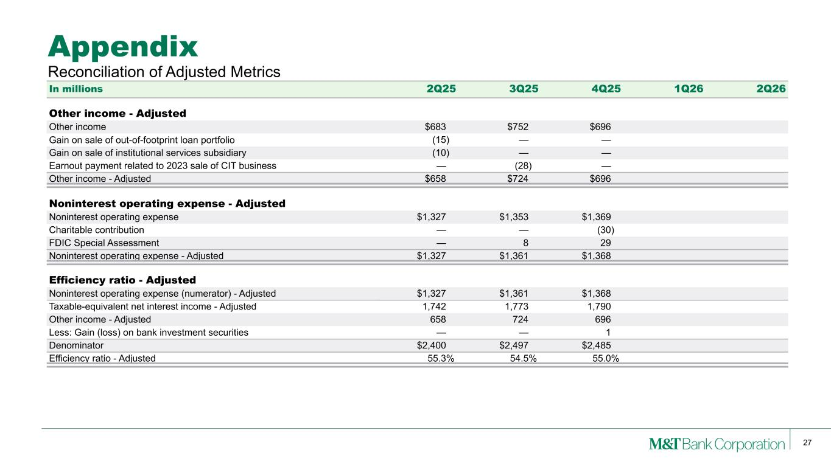
27 Appendix Reconciliation of Adjusted Metrics In millions 2Q25 3Q25 4Q25 1Q26 2Q26 Other income - Adjusted Other income $683 $752 $696 Gain on sale of out-of-footprint loan portfolio (15) — — Gain on sale of institutional services subsidiary (10) — — Earnout payment related to 2023 sale of CIT business — (28) — Other income - Adjusted $658 $724 $696 Noninterest operating expense - Adjusted Noninterest operating expense $1,327 $1,353 $1,369 Charitable contribution — — (30) FDIC Special Assessment — 8 29 Noninterest operating expense - Adjusted $1,327 $1,361 $1,368 Efficiency ratio - Adjusted Noninterest operating expense (numerator) - Adjusted $1,327 $1,361 $1,368 Taxable-equivalent net interest income - Adjusted 1,742 1,773 1,790 Other income - Adjusted 658 724 696 Less: Gain (loss) on bank investment securities — — 1 Denominator $2,400 $2,497 $2,485 Efficiency ratio - Adjusted 55.3% 54.5% 55.0%

